

**UNIVERSITY OF MUMBAI**

**RATYAT SHIKSHAN SANSTH’S**

**KARMVEER BHAURAO PATIL COLLAGE.**

**VASHI, NAVI MUMBAI**

**(2012-2013)**

**A**

**Project Report**

**ON**

**“FERTILIZER SHOP SYSTEM”**

**Exam Seat No:**

**Guided By: Developed By:**

**Mrs.Sarika nahre Sachin.L.Khuspe**

**T.Y. B.Sc. (COMPUTER SCIENCE)**



**UNIVERSITY OF MUMBAI**

**RATYAT SHIKSHAN SANSTH’S**

**KARMVEER BHAURAO PATIL COLLAGE.**

**VASHI, NAVI MUMBAI**

**(2012-2013)**

**A**

**Project Report**

**ON**

**“FERTILIZER SHOP SYSTEM”**

**Exam Seat No:**

**Guided By: Developed By:**

**Mrs.Sarika nahre Sachin.L.Khuspe**

**T.Y. B.Sc. (COMPUTER SCIENCE)**



**UNIVERSITY OF MUMBAI**

**RATYAT SHIKSHAN SANSTH’S**

**KARMVEER BHAURAO PATIL COLLAGE.**

**VASHI, NAVI MUMBAI**

**(2012-2013)**

**(Affiliated to the University Of Mumbai)**

**Certificate of Project**

**“FERTILIZER SHOP SYSTEM”**

**Undertaken at the by:**

**Sachin.L.Khuspe**

**Exam Seat No:**

in partial fulfillment of **B.Sc.(C.S.) Degree e**xamination has not been submitted for any other examination and does not form part of any other course undergone by the candidate. It is further certified that he has completed all required phases of the project.

**Project Guide Principal**

**Internal Guide External Examiner**

**ACKNOWLEDGEMENT**

It is always a difficult task to acknowledge all those who helped me a lot doing this project. Nevertheless I have made an attempt through this report to express my deepest gratitude to all those who have contributed in making of this project either directly or indirectly.

It gives me great pleasure to present my project on **“FERTILIZER SHOP SYSTEM”.** This is my first milestone in B.Sc computer Science.

I would like to express my sincere thanks to my project guide **prof. Mrs. Sarika nahre** who helped me throughout the project.

Last but not the least I am also thankful to my department head **Prof. Mr. Manisha abhyankar** who encourage me and gave me moral support during my project. I would like to thank all my teaching and non-teaching staff of computer science faculty who helped me in completion of my project.

**Yours faithfully**,

**(Sachin.L.Khuspe)**

**INDEX**

|  |  |  |
| --- | --- | --- |
| **Sr.No.** | **Title** | **Page No.** |
| **1** | **Introduction** | **6** |
| **2** | **Gantt Chart** | **7** |
| **3** | **Organizational Overview:** |  |
|  | **a. History.** | **9** |
|  | **b. Organizational Details.** | **10** |
|  | **c. Present System.** | **11** |
|  | **d. Limitations of Present System.** | **12** |
| **4** | **System Analysis** | **14** |
| **5** | **Proposed System** | **17** |
| **6** | **Software Specifications** | **20** |
| **7** | **Hardware Specifications** | **20** |
| **8** | **Feasibility Study** | **22** |
| **9** | **System Documentation:** |  |
|  | **a. Event Table.** | **26** |
|  | **b. Entity Relationship Diagram.** | **27** |
|  | **c. Dataflow Diagram:** |  |
|  | **1) Context Level Diagram.** | **29** |
|  | **2) DFD Fragments.** | **30** |
|  | **d. System Flowchart.** | **33** |
|  | **e. Structure chart.** | **34** |
|  | **f. Menu Tree.** | **35** |
|  | **g. Program List.** | **36** |
|  | **h. Data Table List.** | **37** |
|  | **i. Report List.** | **41** |
|  | **j. System Control and Standards.** | **42** |
|  |  |  |
| **10** | **Program Documentation:** | **43** |
|  | **a. Form Layout and Form Code** | **43** |
| **11** | **Reports** | **92** |
| **12** | **Testing** | **99** |
| **13** | **Limitation and Future Enhancement** | **101** |
| **14** | **Conclusion** | **102** |
| **15** | **Bibliography** | **104** |

**INTRODUCTION**

**This project “FERTILIZER SHOP SYSTEM” is developed using V.B. Dot Net as front end and MS- Access as the back end.**

**The project “FERTILIZER SHOP SYSTEM” has been undertaken for “SHREE SADGURU ENTERPRIZES” with the purpose of keeping all office records marking their manually existing system a computerized one.**

**The project aims at introducing the Computerized Sales Analysis and Purchase planning system for “SHREE SADGURU ENTERPRIZES”**

**This software helps them to keep records of, maintain price lists, analyses sales, purchases done and the purchase planning for products.**

**The project tries to reduce the drawbacks encountered in the manual system and also aims to save time. The project keeps the detail information of the orders taken by the customer. The design created also keeps the records of the previous bills of each order given by the customer.**

**The corner stone of this system is its user friendly and efficient in nature.**

**GANTT CHART**

|  |  |  |  |  |  |  |  |  |  |  |  |  |  |  |  |
| --- | --- | --- | --- | --- | --- | --- | --- | --- | --- | --- | --- | --- | --- | --- | --- |
| **1.** | **Project Search** | **1** |  |  |  |  |  |  |  |  |  |  |  |  |  |
| **2.** | **Finalization** |  | **2** |  |  |  |  |  |  |  |  |  |  |  |  |
| **3.** | **Allocation** |  |  | **3** |  |  |  |  |  |  |  |  |  |  |  |
| **4.** | **Investigation of System Requirements** |  |  |  | **4** |  |  |  |  |  |  |  |  |  |  |
| **5.** | **Data & Process Modeling** |  |  |  |  | **5** |  |  |  |  |  |  |  |  |  |
| **6.** | **System Design** |  |  |  |  |  | **6** |  |  |  |  |  |  |  |  |
| **7.** | **Program Design** |  |  |  |  |  |  |  | **7** |  |  |  |  |  |  |
| **8.** | **Program Coding** |  |  |  |  |  |  |  |  | **8** |  |  |  |  |  |
| **9.** | **Unit Testing** |  |  |  |  |  |  |  |  |  | **9** |  |  |  |  |
| **10.** | **System Integration** |  |  |  |  |  |  |  |  |  |  |  | **10** |  |  |
| **11.** | **System Implementation** |  |  |  |  |  |  |  |  |  |  |  |  | **11** |  |
| **12.** | **Acceptance Testing** |  |  |  |  |  |  |  |  |  |  |  |  |  | **12** |
|  |  |  |  |  |  |  |  |  |  |  |  |  |  |  |  |
|  |  | **W1 W2 W3 W4 W5 W6 W7 W8 W9 W10 W11 W12 W13 W14 W15 W16 W17 W18 W19 W20 W21** | | | | | | | | | | | | | |
|  |  | | | | | | | | | | | | | | |

**Organizational Overview**

**HISTORY**

SHREE SADGURU ENTERPIZES **is the FERTILIZER SHOP where we can get all type Fertilizers. There is also a facility of hearing the songs, which we request. It is one of the most famous Shop in MUMBAI .Daily more than 200 people visit.**

**There is quick availability of Fertilizer and other products.**

**Organizational Profile**

**Name of Organization :**  SHREE SADGURU ENTERPIZES

**Address: KOPARKHAIARANE**

**Phone No. : 8898377219**

**Organization Chart:-**

**Proprieter**

**Manager**

**Reciever**

**Dealer**

**PRESENT SYSTEM**

**In present non-computerized shop management system all the jobs are performed manually. All the records of sale, purchase, stock and customer are written in different register. Accountant will have to maintain all separate registers of each new information. So managing them is very complex and has become a impossible task to be performed manually systematic way. As the job is done manually, it has its own limitations and lot’s of paperwork. Preparation of records on daily and monthly basis becomes a tedious and time consuming job and still its authentic is always debatable and can’t be verified easily.**

**The daily and monthly records which are done manually are not easy to maintain in files or registers which can be destroyed anytime by any person.**

**Time required for searching records of particular day sale information is more. Maintaining the records of stock in register is also very difficult.**

**In present system entire work depend upon sales and purchase. Billing is also done manually; it takes lots of time and throws open doors manipulation and updating of records they can be done by cashier. Bill is not readable which creates confusion in customer as well as owner. Any manual error can be lead to wrong result.**

**This system unable to provide timely report information.**

**Limitations of Present System**

# The current system work is manual and person dependent.

# All the entries are kept in worksheets. So, there is risk of arising mistake.

# It can be used for any product and does not get affected by seasons.

# There are chances of losing some important data because the records are entered manually.

# It is must to update records at regular intervals.

**SYSTEM ANALYSIS**

**System Study:**

**The Planning Phase:**

**The primary objectives of this phase are to identify the scope of the new system, ensures that the project is feasible, develop a schedule, allocate the resources & budget for the remainder of the project.**

**The four activities in the project planning phase**

1. **Define the problem**
2. **Confirm the project feasibility**
3. **Produce the project scheduled**
4. **Launch the project**

**The Analysis Phase:**

**The primary objectives of this phase are to understand the business needs & processing requirements of the new system. Analysis is essential to find out the process of business. There are five primary activities.**

1. **Gather the Information**
2. **Define the system requirements**
3. **Build prototype for requirements**
4. **Generate and evaluate alternatives**
5. **Review recommendation with management**

**The Design Phase:**

**The objectives of design phase are to design solution for the system. High-level design consists of developing an architecture structure for software programming; database, the user interface, & the operating environment .Design activity are closely interrelated.**

1. **Design an integrate network**
2. **Design the application architecture**
3. **Design the user interface**
4. **Design the system interface**
5. **Design the integrated database**
6. **Design & integrate the system controls**

**The Implementation Phase:**

**During the implementation phase the final system is ready to install.**

**The objectives of this phase is not only to have reliable ,working information system but also to ensures that the user are all trained and that the business is benefiting .This phase**

**Have four major activities.**

1. **Construct the software component**
2. **Verify the testing**
3. **Train and documentation**
4. **Install the system**

**PROPOSED SYSTEM**

**The Benefits of Computerized System:**

* **All the information about sale, purchase, stock will be maintain properly in this system.**
* **All manual calculation of sale or all the money management will be performed by the computer automatically.**
* **This system will provide timely report information.**
* **It will produce report for sale, bill and stock information.**
* **The computer can hold amount of data in its storage device.**
* **The operation and speed of the computer is very high.**
* **We can calculate result and print any report with in seconds.**
* **Any difficulties we can solve easily.**
* **A database application can be stored in computer effectively.**
* **It is very user friendly and easy to handle.**

**So the computerized system is more suitable than the manual system.**

Advantages of the Proposed System

* **Maintains record about various customers easily.**
* **Facility to maintain multiple addresses and contact(s) details of customers, clients.**
* **Facility to maintain FERTILIZERS price lists.**
* **Facility to capture customer and order type information in the sales order.**
* **Facility to change selected order information after order release.**
* **Efficient and user friendly.**

**CONCLUSION:**

**The computerized system is certainly modernized and many advantages than manual system.**

**During the study of this project the following points are considered:**

* **Manpower requires for searching is very less.**
* **Time requires is very less.**
* **Accuracy is more than manual system.**
* **Getting result within time**.

**HARDWARE & SOFTWARE SPECIFICATION**

**HARDWARE USED:**

|  |  |
| --- | --- |
| **PC** | Intel based PC (Pentium IV Processor) |
| **Monitor** | Monitor having capacity of resolution 1024 X 768 Pixels |
| **Input and Pointing devices** | Standards 107 keys and mouse |
| **RAM** | Minimum 512 MB Ram |
| **Minimum Hard Disk** | 2 GB |

**SOFTWARE USED:**

|  |  |
| --- | --- |
| **Operating System** | Windows XP Professional or Windows 98 |
| **Front End Tool** | VB .Net2008 |
| **Back End Tool** | Microsoft SQL SERVER 2005 |
| **For Documentation** | Microsoft Office Word 2007 |

**About Microsoft VB.NET Enterprise Edition:**

**VB.NET is great! It’s an easy, economical, and fast application-development tool; it’s a good prototyping tool, and developer’s love using it. Like any high-level programming language, VB.NET lets the programmer write really awful programs, and with VB.NET, you can screw up more easily and faster than ever! As with programs in any language, a bad program in**

**VB.NET can be very hard to maintain. It can be hard to adapt to meet changing business requirements. But with Visual Basic programs, there is a greater danger than with other languages that developer will focus too much on a pretty front end without designing a solid structure on which to hang it. Important business logic can be attached to GUI widgets rather than placed in reusable objects, making it hard to share and reuse code.**

**About Backend- Microsoft SQL SERVER 2005:**

**SQL server is a database provided by Microsoft. It is one of the many**

**Databases used in web application and also one of the simplest to use as compared to others.**

**The database is a collection of information that is related to particular subject or purpose such as tracking user information or maintaining user list etc.**

**By using SQL server, all the information can be stored and retrieved to and from single database file. Data is divided into separate containers called tables SQL can match related records from more than one table so that you can bring them together in firm, report or query. A unique identity distinguishes one record from another.**

**For the Fertilizer Shop Management provider connection is used.**

**The connection is created which is mapped to the database**

**Driver used is**

**FEASIBILITY STUDY**

**A Feasibility study is the study of positive possibilities of the project. It is also measure of how beneficial or practical development of information system would be to an organization.**

**Feasibility study involves following important parts:**

**TECHNICAL FEASIBILITY**

**Technical feasibility analysis determines whether the proposed system can be developed & implemented using existing technologies or whether new technologies are required. Hardware, software and network requirements are also determined.**

* **The System is very time restricted, speed and storage requirement are very less.**
* **As the system is now computerized the software requirements needs:**

**FRONTEND:** **VB>NET**

**BACKEND:** **SQL Server 2005**

**OPERATING SYSTEM: WINDOWS 98 / 2000 / XP**

* **Proposed equipment should hold data required for using new system.**
* **It should provide accuracy, reliability and ease of accessing data security.**

**OPERATION FEASIBILITY:**

**Project would be beneficial if the information system should meet the operating requirements of organization & should fit its organization culture.**

**ECONOMICAL FEASIBILITY:**

**A system that can be developed technically and that will be used if installed must still be a good investment for the organization. Economic feasibility analysis evaluates the financial aspects of the project by performing a cost-benefit analysis to see if the investments made in creating/developing a new system is costlier or more beneficial. The overall cost of hardware & software for Fertilizer shop was found to be within scope of funds allocated to this system development.**

**Financial benefits must equal or exceed the costs. To assure this one mist estimate following:**

* **The cost to conduct a full system investigation**
* **The cost of hardware and software for the class of application being considered.**
* **The benefits in the form of reduced costs or fewer costly errors.**
* **The cost if nothing changes (i.e. the proposed system is not developed) for a project to be judged feasible, it must pass all these tests. If any one of these issues appears infeasible the decision must be reconsidered**

**SYSTEM DOCUMENTATION**

|  |  |  |  |  |  |
| --- | --- | --- | --- | --- | --- |
| **Event**  ***Event Table*** | **Trigger** | **Source** | **Activity** | **Response** | **Destination** |
| **Product availability** | **Product inquiry** | **Customer** | **Look up Product**  **Availability** | **Product availability detail** | **Customer** |
| **Customer place an order** | **New order of Product** | **Customer** | **Create New order** | **Order confirmation** | **Customer** |
| **Customer change or cancel order** | **Product change request** | **Customer** | **Update Product order** | **Change confirmation**  **Customer** |
| **Customer return Product** | **Product return Notice** | **Customer** | **Create Product return** | **Return confirmation** | **Customer & admin** |
| **Generation of report** | **Generate report** | **Customer** | **Generating report** | **Report generated** | **Shopkeeper** |
| **Shopkeeper check Product status** | **Product status inquiry** | **Customer & shopkeeper** | **Lookup Product status** | **Product status detail** | **Shopkeeper** |

##### Entity-Relationship Diagram



**DATAFLOW DIAGRAM**

Context Level Dataflow Diagram

FERTILIZER

SHOP MANAGEMENT SYSTEM

Product Enter & Update

Details

Product Details

Product

Administrator

Order Request Generate Bill &

Order Details

Customer

Get Bill & Order

Order

# DFD Fragments

DFD

1

Look Up Product

Availability

Customer

Prd Details

Prd Enquiry

Prod Issue

**Payment**

Customer

Prod Order

Confirmation

Customer

2

Create New

Order

New Prd

Order

3

Update

Order

Customer

Change

Request

Change

Confirmation

Prd Detail

Order Detail

Issue Detail

4

Look Up

Prod Status

Customer

Order

Status

Order Status Detail

Prod Issues

Customer

Prd Return

Customer

Payment

Prd Issue return

Prd Return

Return Confirmation

5

Create Prd

Order Return

**PrdDetail**

**6**

**Generate**

**Report**

**Customer**

**Shopkeeper**

**Prd Return**

**Prd Issue Return**

**Prd Issues**

**Prd Details**

**Payment**

**FLOW CHART**

**Attendance Report of shopkeeper**

**Product Report**

**Customer**

**Period of Product**

**Payment Detail**

**Owner**

**Shopkeeper**

**Customer**

**Structure Chart**

Prd order

Prd issues

Shopkeeper

Prd Inquiry

**SALES System**

Prd Detail

Customer

Product Order return

Update Order

Genrate Report

Product Status

Create New Order

Look Up ProductAvailability

**MENU TREE**

**MDIFORM**

**TRANSACTION**

**REGISTERS**

**TOOLS**

**EXIT**

**MASTER**

CUSTOMER

CALENDER

MRN

PRODUCT

EMPLOYEE

CALCULATOR

ORDER

EMPLOYEE

SUPPLIER

DISPATCH

CUSTOMER

BILL

BILL

SUPPLIER

**PROGRAM LIST**

|  |  |
| --- | --- |
| FORM NAME | DESCRIPTION |
| LoginForm.vb | The functionality of this form is to authorize the user and give the access to the user depending on the user name and password. |
| SplashForm.vb | The functionality of this form is to give some information about the software like its version,platform on which it is able to execute. |
| MDIForm.vb | The functionality of this form is to provide the list of menus that facilitates the user to accsee the different forms or programs. |
| ProductForm.vb | The functionality of this form is to collect details regarding the Product. |
| EmployeeForm.vb | The functionality of this form is to store the Employee details. |
| CustomerForm.vb | The functionality of this form is to store the Customer information. |
| SupplierForm.vb | The functionality of this form is to store the Supplier details. |
| MRNForm.vb | The functionality of this form is to store the availability and product information. |
| OrderForm.vb | The functionality of this form is to store the Order Details. |
| DispatchForm.vb | The functionality of this form is to store the Dispatch information. |
| BillForm.vb | The functionality of this form is to store the Bill details. |

**DATA DICTIONARY**

**1) Table Name : ProductInfo**

|  |  |  |
| --- | --- | --- |
| **Field** | **DataType** | **Size** |
| Prdid | Text | 50 |
| Prdname | Text | 50 |
| Prdqty | Text | 50 |
| Prddescription | Text | 50 |
| Qtyonhand | Text | **-** |
| Reorderlevel | Text | - |
| Price | Currency | Long Integer |

**2)Table Name : CustomerInfo**

|  |  |  |
| --- | --- | --- |
| **Field** | **DataType** | **Size** |
| Custid | Text | 50 |
| Custname | Text | 50 |
| Phno | Text | **-** |
| Address | Text | **-** |
| Pincode | Text | 50 |
| Gender | - | **-** |
| EMail | Text | 50 |

**3)Table Name : EmployeeInfo**

|  |  |  |
| --- | --- | --- |
| **Field** | **DataType** | **Size** |
| Empid | Text | 50 |
| Empname | Text | 50 |
| Phno | Text | **-** |
| Address | Text | 50 |
| EMail | Text | 50 |
| Gender | _ |  |
| Birthate | Date/Time |  |
| Designation | Text |  |
| Joindate | Date/Time |  |
| Salary | Text |  |

|  |  |  |
| --- | --- | --- |
| **Field** | **DataType** | **Size** |
| Supid | Text | 50 |
| Supname | Text | 50 |
| Phno | Text | **-** |
| Address | Text | **-** |
| Pincode | Text |  |
| EMID | Text |  |
| Prodname | Text |  |

**4)Table Name : SupplierInfo**

**5)Table Name : MRNINFO**

|  |  |  |
| --- | --- | --- |
| **Field** | **DataType** | **Size** |
| Mrnid | Text | 50 |
| Mdate | Date/Time | 50 |
| MSuppliers | Text | **-** |
| MProdid | Text | Long Integer |
| MProdname | Text | Long Integer |
| MQtyrecvd | Text |  |
| MQtyreject | Text |  |
| MTotal | Text |  |

|  |  |  |
| --- | --- | --- |
| **Field** | **DataType** | **Size** |
| Ordid | Text | 50 |
| Messers | Text | 50 |
| Prdnum | Text | 50 |
| Prdname | Text | 50 |
| Date | Date/Time | **-** |
| Quty | Text | **-** |
| Rate | Text | 50 |
| Amt | Text |  |

**6**)**Table Name : OrderInfo**

**7**)**Table Name : DispatchInfo**

|  |  |  |
| --- | --- | --- |
| **Field** | **DataType** | **Size** |
| Dispno | Text | 50 |
| Date | Date/Time | 50 |
| Dispto | Text | 50 |
| Dispfrm | Text | 50 |
| Qtysend | Text | **-** |
| Qtyrcvd | Text | **-** |

**8**)**Table Name : BillInfo**

|  |  |  |
| --- | --- | --- |
| **Field** | **DataType** | **Size** |
| Bid | Text | 50 |
| Date | Date/Time | 50 |
| Messers | Text | 50 |
| Pid | Text | 50 |
| Prdname | Text | **-** |
| Qty | Text | **-** |
| Rate | Text | 50 |
| Amt | Text |  |

**REPORT – LIST**

|  |  |  |
| --- | --- | --- |
| **Sr.No** | **Name of the Report** | **Description** |
| 1 | CustReport | It displays customer details. |
| 2 | EmployeeReport | It displays employee details. |
| 3 | SupplierReport | It displays Supplier details. |
| 4 | BillReport | It displays the details about the total Bill. |

# System Controls And Standards

* **Access Control:**

This system gives access only to the authorized user by accepting username and password and also depending on username and password system can give the limited scope in it for security purpose.

* **Input control:**

This system validates every textbox or by which user gives input to the system.It validates textual data as well as numeric data.

**It does not allow the user to enter any bad or invalid data.**

**Any wrong input will not be accepted and user will be instructed by the proper message.**

* **System Generated Controls:**

In this system whenever product details is entered the system checks that whether all the required detail is present and does not allow any wrong data.It instructs the user with proper message.

* **Range Control:**

In the Indradhanu Enterprizes the maximum product that can be entered by the user depends on the selected by him.

**PROGRAM CODING**

**AND**

**FORM LAYOUTS**

## SplashScreenForm.vb

**Program Name:** SplashscreenForm.vb

**Program Function:** This is form is used to Load the system



## SplashScreenForm.vb

Public Class SplashScreenForm

Private Sub Timer1_Tick(ByVal sender As System.Object, ByVal e As System.EventArgs) Handles Timer1.Tick

If (ProgressBar1.Value < 100) Then

ProgressBar1.Value = ProgressBar1.Value + 5

Label1.Text = ProgressBar1.Value & "%"

End If

If (ProgressBar1.Value = 100) Then

Timer1.Enabled = False

Me.Hide()

LoginForm.Show()

End If

End Sub

End Class

## 

## 

## 

## LoginForm.vb

**Program Name:** LoginForm.vb

**Program Function:** This is form is used to Login in the system

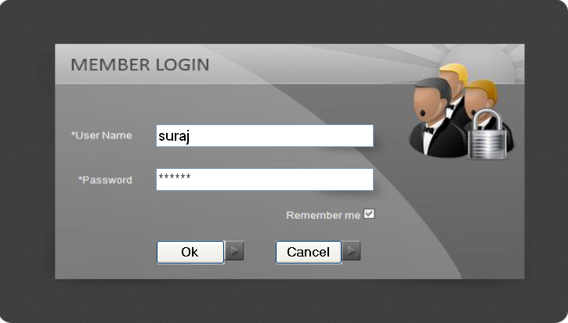

## LoginForm.vb

Imports System.Data

Imports System.Data.OleDb

Public Class LoginForm

Private Sub Button1_Click(ByVal sender As System.Object, ByVal e As System.EventArgs) Handles Button1.Click

Dim str2 As String

Dim str3 As String

str2 = TextBox1.Text

str3 = TextBox2.Text

Dim con As New OleDbConnection("Provider=Microsoft.ACE.OLEDB.12.0;Data Source=|DataDirectory|\Login.accdb")

con.Open()

Dim cmd2 As New OleDbCommand("select * from Login_Table", con)

Dim reader As OleDbDataReader

reader = cmd2.ExecuteReader

While reader.Read

Dim login_name As String

Dim pas As String

login_name = reader(0)

pas = reader(1)

Dim i As Integer

Dim j As Integer

If (i = String.Compare(login_name, str2)) And (j = String.Compare(pas, str3)) Then

Me.Hide()

MDIForm.Show()

Else

MsgBox("Login Unsuccess")

End If

End While

End Sub

Private Sub Button2_Click(ByVal sender As System.Object, ByVal e As System.EventArgs) Handles Button2.Click

Me.Close()

End Sub

End Class

**MDIForm.vb**

**Program Name:** MDIForm.vb

**Program Function:** This is form contains menus i.e. path for other forms.



**MDIForm.vb**

Public Class MDIForm

Private Sub PRODUCTToolStripMenuItem_Click(ByVal sender As System.Object, ByVal e As System.EventArgs) Handles PRODUCTToolStripMenuItem.Click

ProductForm.MdiParent = Me

ProductForm.Show()

End Sub

Private Sub EMPLOYEEToolStripMenuItem_Click(ByVal sender As System.Object, ByVal e As System.EventArgs) Handles EMPLOYEEToolStripMenuItem.Click

EmployeeForm.MdiParent = Me

EmployeeForm.Show()

End Sub

Private Sub CUSTOMERToolStripMenuItem_Click(ByVal sender As System.Object, ByVal e As System.EventArgs) Handles CUSTOMERToolStripMenuItem.Click

CustomerForm.MdiParent = Me

CustomerForm.Show()

End Sub

Private Sub SUPPLIERToolStripMenuItem_Click(ByVal sender As System.Object, ByVal e As System.EventArgs) Handles SUPPLIERToolStripMenuItem.Click

SupplierForm.MdiParent = Me

SupplierForm.Show()

End Sub

Private Sub MRNToolStripMenuItem_Click(ByVal sender As System.Object, ByVal e As System.EventArgs) Handles MRNToolStripMenuItem.Click

MRNForm.MdiParent = Me

MRNForm.Show()

End Sub

Private Sub ORDERToolStripMenuItem_Click(ByVal sender As System.Object, ByVal e As System.EventArgs) Handles ORDERToolStripMenuItem.Click

OrderForm.MdiParent = Me

OrderForm.Show()

End Sub

Private Sub DISPATCHToolStripMenuItem_Click(ByVal sender As System.Object, ByVal e As System.EventArgs) Handles DISPATCHToolStripMenuItem.Click

DispatchForm.MdiParent = Me

DispatchForm.Show()

End Sub

Private Sub BILLToolStripMenuItem_Click(ByVal sender As System.Object, ByVal e As System.EventArgs) Handles BILLToolStripMenuItem.Click

BillForm.MdiParent = Me

BillForm.Show()

End Sub

Private Sub CustReportToolStripMenuItem_Click(ByVal sender As System.Object, ByVal e As System.EventArgs) Handles CustReportToolStripMenuItem.Click

CustReport.Show()

End Sub

Private Sub EmployeeReportToolStripMenuItem_Click(ByVal sender As System.Object, ByVal e As System.EventArgs) Handles EmployeeReportToolStripMenuItem.Click

EmpReport.Show()

End Sub

Private Sub SupplierReportToolStripMenuItem_Click(ByVal sender As System.Object, ByVal e As System.EventArgs) Handles SupplierReportToolStripMenuItem.Click

SupplierReport.Show()

End Sub

Private Sub BillReportToolStripMenuItem1_Click(ByVal sender As System.Object, ByVal e As System.EventArgs) Handles BillReportToolStripMenuItem1.Click

BillReport.Show()

End Sub

Private Sub CALCULATORToolStripMenuItem_Click(ByVal sender As System.Object, ByVal e As System.EventArgs) Handles CALCULATORToolStripMenuItem.Click

Calender.MdiParent = Me

Calender.Show()

End Sub

Private Sub CALENDERToolStripMenuItem_Click(ByVal sender As System.Object, ByVal e As System.EventArgs) Handles CALENDERToolStripMenuItem.Click

Try

Process.Start("C:\WINDOWS\system32\calc.exe")

Catch ex As Exception

End Try

End Sub

Private Sub EXITToolStripMenuItem_Click(ByVal sender As System.Object, ByVal e As System.EventArgs) Handles EXITToolStripMenuItem.Click

Me.Close()

GoodbyeForm.Show()

End Sub

End Class

**ProductForm.vb**

**Program Name:** ProductForm.vb

**Program Function:** This is form is use to add new Products

**Data entry form:**

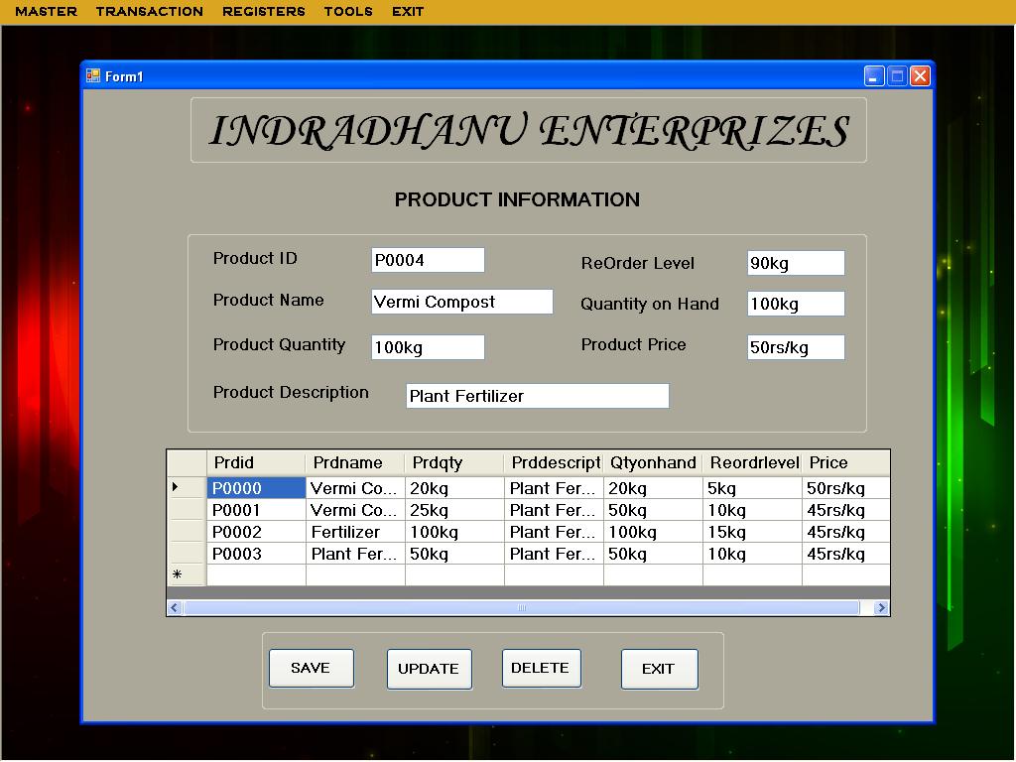

**ProductForm.vb**

Imports System.Data.OleDb

Public Class ProductForm

Dim h As helper = New helper

Dim dv As DataView

Private Sub ProductForm_Load(ByVal sender As System.Object, ByVal e As System.EventArgs) Handles MyBase.Load

Dim con As OleDb.OleDbConnection = New OleDb.OleDbConnection("Provider=Microsoft.ACE.OLEDB.12.0;Data Source=|DataDirectory|\Login.accdb")

Dim cmd As OleDb.OleDbCommand = New OleDb.OleDbCommand("select * from ProductInfo", con)

Dim ds = New DataSet()

con.Open()

Dim da As OleDb.OleDbDataAdapter = New OleDb.OleDbDataAdapter(cmd)

da.Fill(ds, "ProductInfo")

dv = New DataView(ds.Tables(0))

dgvpat.DataSource = dv

'Clear binding

'

TextBox1.DataBindings.Clear()

TextBox2.DataBindings.Clear()

TextBox3.DataBindings.Clear()

TextBox4.DataBindings.Clear()

TextBox5.DataBindings.Clear()

TextBox6.DataBindings.Clear()

TextBox7.DataBindings.Clear()

'

'data binding

'

TextBox1.DataBindings.Add("text", dv, "Prdid")

TextBox2.DataBindings.Add("text", dv, "Prdname")

TextBox3.DataBindings.Add("text", dv, "Prdqty")

TextBox6.DataBindings.Add("text", dv, "Price")

TextBox5.DataBindings.Add("text", dv, "Qtyonhand")

TextBox7.DataBindings.Add("text", dv, "Reordrlevel")

TextBox4.DataBindings.Add("text", dv, "Prddescription")

cmd.ExecuteNonQuery()

con.Close()

End Sub

Private Sub Button1_Click(ByVal sender As System.Object, ByVal e As System.EventArgs) Handles Button1.Click

If Button1.Text = "ADD" Then

Button1.Text = "SAVE"

TextBox1.Text = ""

TextBox2.Text = ""

TextBox3.Text = ""

TextBox4.Text = ""

TextBox5.Text = ""

TextBox6.Text = ""

TextBox7.Text = ""

Dim con As OleDb.OleDbConnection = New OleDb.OleDbConnection("Provider=Microsoft.ACE.OLEDB.12.0;Data Source=|DataDirectory|\Login.accdb")

Dim cmd1 As OleDb.OleDbCommand = New OleDb.OleDbCommand("select max(Prdid) from ProductInfo", con)

Dim ds1 As DataSet = New DataSet()

Dim da1 As OleDb.OleDbDataAdapter = New OleDb.OleDbDataAdapter(cmd1)

con.Open()

da1.Fill(ds1, "ProductInfo")

Dim str, code As String

Dim id As Integer

str = ds1.Tables(0).Rows(0).Item(0).ToString()

code = str.Substring(1, 4)

id = CUInt(code)

If (id >= 0 And id < 9) Then

id = id + 1

TextBox1.Text = "P000" & id

ElseIf (id >= 9 And id < 99) Then

id = id + 1

TextBox1.Text = "P00" & id

ElseIf (id >= 99 And id < 999) Then

id = id + 1

TextBox1.Text = "P0" & id

ElseIf (id > 999) Then

id = id + 1

TextBox1.Text = "P" & id

End If

cmd1.ExecuteNonQuery()

con.Close()

Else

If (TextBox2.Text = "" Or TextBox3.Text = "" Or TextBox4.Text = "" Or TextBox5.Text = "" Or TextBox6.Text = "" Or TextBox7.Text = "") Then

MsgBox("Please Fill The Blank Field(s) !!", MsgBoxStyle.OkOnly)

Else

h.AMD("Insert into ProductInfo values('" + TextBox1.Text + "','" + TextBox2.Text + "','" + TextBox3.Text + "','" + TextBox4.Text + "','" + TextBox5.Text + "','" + TextBox6.Text + "','" + TextBox7.Text + "')", "Record Inserted Succesfully")

Button1.Text = "ADD"

ProductForm_Load(Nothing, Nothing)

End If

End If

End Sub

Private Sub Button2_Click(ByVal sender As System.Object, ByVal e As System.EventArgs) Handles Button2.Click

If Button2.Text = "UPDATE" Then

Button2.Text = "MODIFY"

Dim con As OleDb.OleDbConnection = New OleDb.OleDbConnection("Provider=Microsoft.ACE.OLEDB.12.0;Data Source=|DataDirectory|\Login.accdb")

Dim cmd1 As OleDb.OleDbCommand = New OleDb.OleDbCommand("select * from ProductInfo where Prdid='" + TextBox1.Text + "'", con)

Dim ds1 As DataSet = New DataSet()

Dim da1 As OleDb.OleDbDataAdapter = New OleDb.OleDbDataAdapter(cmd1)

con.Open()

Else

h.AMD("Update ProductInfo set Prdname='" + TextBox2.Text + "',Prdqty='" + TextBox3.Text + "',Prddescription='" + TextBox4.Text + "',Qtyonhand='" + TextBox5.Text + "',Price='" + TextBox6.Text + "',Reordrlevel='" + TextBox7.Text + "'WHERE Prdid='" + TextBox1.Text + "'", "Record Updated Succesfully")

Button2.Text = "UPDATE"

ProductForm_Load(Nothing, Nothing)

End If

End Sub

Private Sub Button3_Click(ByVal sender As System.Object, ByVal e As System.EventArgs) Handles Button3.Click

Dim con As OleDb.OleDbConnection = New OleDb.OleDbConnection("Provider=Microsoft.ACE.OLEDB.12.0;Data Source=|DataDirectory|\Login.accdb")

Dim cmd1 As OleDb.OleDbCommand = New OleDb.OleDbCommand("select * from ProductInfo", con)

Dim ds1 As DataSet = New DataSet()

Dim da1 As OleDb.OleDbDataAdapter = New OleDb.OleDbDataAdapter(cmd1)

con.Open()

da1.Fill(ds1, "ProductInfo")

h.AMD("Delete From ProductInfo where Prdid='" + TextBox1.Text + "' ", "Record Deleted Succesfully")

ProductForm_Load(Nothing, Nothing)

End Sub

Private Sub Button4_Click(ByVal sender As System.Object, ByVal e As System.EventArgs) Handles Button4.Click

Dim s As String

s = MsgBox("Do You Want To EXIT", MsgBoxStyle.YesNo)

If s = vbYes Then

Me.Close()

Else

End If

End Sub

Private Sub TextBox2_KeyPress(ByVal sender As Object, ByVal e As System.Windows.Forms.KeyPressEventArgs) Handles TextBox2.KeyPress

If Char.IsLetter(e.KeyChar) = False And Asc(e.KeyChar) <> 8 And Char.IsWhiteSpace(e.KeyChar) = False Then

e.Handled = True

MsgBox("Enter Only Letters")

End If

End Sub

Private Sub TextBox3_KeyPress(ByVal sender As Object, ByVal e As System.Windows.Forms.KeyPressEventArgs) Handles TextBox3.KeyPress

If Char.IsNumber(e.KeyChar) = False And Asc(e.KeyChar) <> 8 Then

e.Handled = True

MsgBox("Enter Only Numbers")

End If

End Sub

Private Sub TextBox4_KeyPress(ByVal sender As Object, ByVal e As System.Windows.Forms.KeyPressEventArgs) Handles TextBox4.KeyPress

If Char.IsLetter(e.KeyChar) = False And Asc(e.KeyChar) <> 8 And Char.IsWhiteSpace(e.KeyChar) = False Then

e.Handled = True

MsgBox("Enter Only Letters")

End If

End Sub

Private Sub TextBox5_KeyPress(ByVal sender As Object, ByVal e As System.Windows.Forms.KeyPressEventArgs) Handles TextBox5.KeyPress

If Char.IsNumber(e.KeyChar) = False And Asc(e.KeyChar) <> 8 Then

e.Handled = True

MsgBox("Enter Only Numbers")

End If

End Sub

Private Sub TextBox6_KeyPress(ByVal sender As Object, ByVal e As System.Windows.Forms.KeyPressEventArgs) Handles TextBox6.KeyPress

If Char.IsNumber(e.KeyChar) = False And Asc(e.KeyChar) <> 8 Then

e.Handled = True

MsgBox("Enter Only Numbers")

End If

End Sub

Private Sub TextBox7_KeyPress(ByVal sender As Object, ByVal e As System.Windows.Forms.KeyPressEventArgs) Handles TextBox7.KeyPress

If Char.IsNumber(e.KeyChar) = False And Asc(e.KeyChar) <> 8 Then

e.Handled = True

MsgBox("Enter Only Numbers")

End If

End Sub

End Class

**Test Result :**

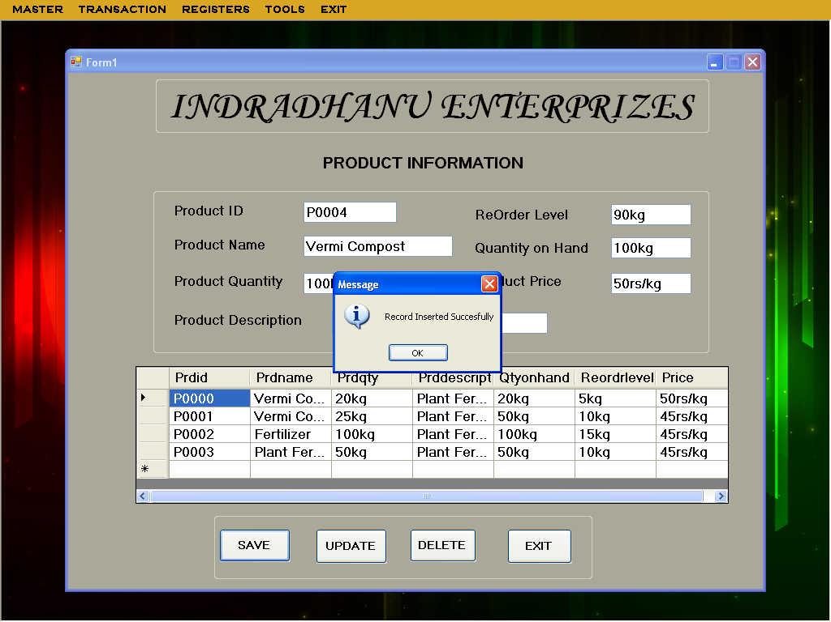

**EmployeeForm.vb**

**Program Name:** EmployeeForm.vb

**Program Function:** This is form is use to add new empolyee

**Data entry form:**

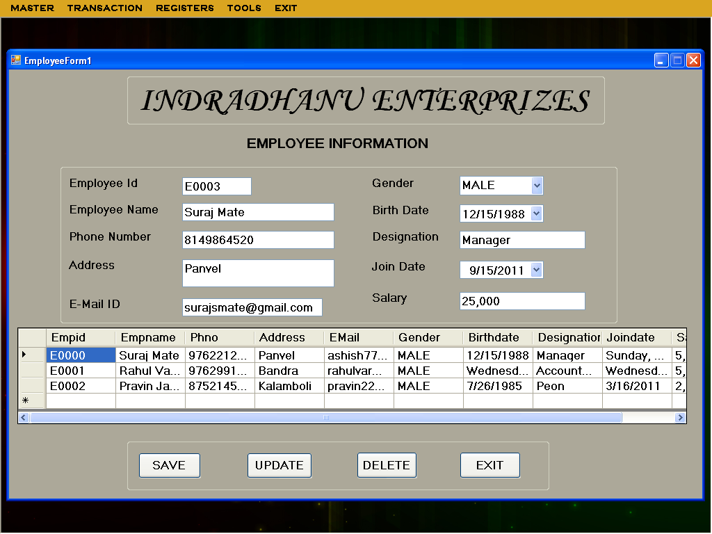

**EmployeeForm.vb**

'

Imports System.Data.OleDb

Public Class EmployeeForm

Dim h As helper = New helper

Dim dv As DataView

Private Sub EmployeeForm_Load(ByVal sender As System.Object, ByVal e As System.EventArgs) Handles MyBase.Load

Dim con As OleDb.OleDbConnection = New OleDb.OleDbConnection("Provider=Microsoft.ACE.OLEDB.12.0;Data Source=|DataDirectory|\Login.accdb")

Dim cmd As OleDb.OleDbCommand = New OleDb.OleDbCommand("select * from EmployeeInfo", con)

Dim ds = New DataSet()

con.Open()

Dim da As OleDb.OleDbDataAdapter = New OleDb.OleDbDataAdapter(cmd)

da.Fill(ds, "EmployeeInfo")

dv = New DataView(ds.Tables(0))

dgvpat.DataSource = dv

'Clear binding

'

TextBox1.DataBindings.Clear()

TextBox2.DataBindings.Clear()

TextBox3.DataBindings.Clear()

TextBox4.DataBindings.Clear()

TextBox5.DataBindings.Clear()

ComboBox1.DataBindings.Clear()

DateTimePicker1.DataBindings.Clear()

TextBox6.DataBindings.Clear()

DateTimePicker2.DataBindings.Clear()

TextBox7.DataBindings.Clear()

'

'data binding

'

TextBox1.DataBindings.Add("text", dv, "Empid")

TextBox2.DataBindings.Add("text", dv, "Empname")

TextBox3.DataBindings.Add("text", dv, "Phno")

TextBox4.DataBindings.Add("text", dv, "Address")

TextBox5.DataBindings.Add("text", dv, "EMail")

ComboBox1.DataBindings.Add("text", dv, "Gender")

DateTimePicker1.DataBindings.Add("text", dv, "Birthdate")

TextBox6.DataBindings.Add("text", dv, "Designation")

DateTimePicker2.DataBindings.Add("text", dv, "Joindate")

TextBox7.DataBindings.Add("text", dv, "Salary")

cmd.ExecuteNonQuery()

con.Close()

End Sub

Private Sub ADD_Click(ByVal sender As System.Object, ByVal e As System.EventArgs) Handles Button1.Click

If Button1.Text = "ADD" Then

Button1.Text = "SAVE"

TextBox1.Text = ""

TextBox2.Text = ""

TextBox3.Text = ""

TextBox4.Text = ""

TextBox5.Text = ""

ComboBox1.Text = ""

DateTimePicker1.Text = ""

TextBox6.Text = ""

DateTimePicker2.Text = ""

TextBox7.Text = ""

Dim con As OleDb.OleDbConnection = New OleDb.OleDbConnection("Provider=Microsoft.ACE.OLEDB.12.0;Data Source=|DataDirectory|\Login.accdb")

Dim cmd1 As OleDb.OleDbCommand = New OleDb.OleDbCommand("select max(Empid) from EmployeeInfo", con)

Dim ds1 As DataSet = New DataSet()

Dim da1 As OleDb.OleDbDataAdapter = New OleDb.OleDbDataAdapter(cmd1)

con.Open()

da1.Fill(ds1, "EmployeeInfo")

Dim str, code As String

Dim id As Integer

str = ds1.Tables(0).Rows(0).Item(0).ToString()

code = str.Substring(1, 4)

id = CUInt(code)

If (id >= 0 And id < 9) Then

id = id + 1

TextBox1.Text = "E000" & id

ElseIf (id >= 9 And id < 99) Then

id = id + 1

TextBox1.Text = "E00" & id

ElseIf (id >= 99 And id < 999) Then

id = id + 1

TextBox1.Text = "E0" & id

ElseIf (id > 999) Then

id = id + 1

TextBox1.Text = "E" & id

End If

cmd1.ExecuteNonQuery()

con.Close()

Else

If (TextBox2.Text = "" Or TextBox3.Text = "" Or TextBox4.Text = "" Or TextBox5.Text = "" Or ComboBox1.Text = "" Or DateTimePicker1.Text = "" Or TextBox6.Text = "" Or DateTimePicker2.Text = "" Or TextBox7.Text = "") Then

MsgBox("Please Fill The Blank Field(s) !!", MsgBoxStyle.OkOnly)

Else

h.AMD("Insert into EmployeeInfo values('" + TextBox1.Text + "','" + TextBox2.Text + "','" + TextBox3.Text + "','" + TextBox4.Text + "','" + TextBox5.Text + "','" + ComboBox1.Text + "','" + DateTimePicker1.Text + "','" + TextBox6.Text + "','" + DateTimePicker2.Text + "','" + TextBox7.Text + "')", "Record Inserted Succesfully")

Button1.Text = "ADD"

EmployeeForm_Load(Nothing, Nothing)

End If

End If

End Sub

Private Sub Button2_Click(ByVal sender As System.Object, ByVal e As System.EventArgs) Handles Button2.Click

If Button2.Text = "UPDATE" Then

Button2.Text = "MODIFY"

Dim con As OleDb.OleDbConnection = New OleDb.OleDbConnection("Provider=Microsoft.ACE.OLEDB.12.0;Data Source=|DataDirectory|\Login.accdb")

Dim cmd1 As OleDb.OleDbCommand = New OleDb.OleDbCommand("select * from EmployeeInfo where Empid='" + TextBox1.Text + "'", con)

Dim ds1 As DataSet = New DataSet()

Dim da1 As OleDb.OleDbDataAdapter = New OleDb.OleDbDataAdapter(cmd1)

con.Open()

Else

h.AMD("Update EmployeeInfo set Empname='" + TextBox2.Text + "',Phno='" + TextBox3.Text + "',Address='" + TextBox4.Text + "',EMail='" + TextBox5.Text + "',Gender='" + ComboBox1.Text + "',Birthdate='" + DateTimePicker1.Text + "',Designation='" + TextBox6.Text + "',Joindate='" + DateTimePicker2.Text + "',Salary='" + TextBox7.Text + "'WHERE Empid='" + TextBox1.Text + "'", "Record Updated Succesfully")

Button2.Text = "UPDATE"

EmployeeForm_Load(Nothing, Nothing)

End If

End Sub

Private Sub Button3_Click(ByVal sender As System.Object, ByVal e As System.EventArgs) Handles Button3.Click

Dim con As OleDb.OleDbConnection = New OleDb.OleDbConnection("Provider=Microsoft.ACE.OLEDB.12.0;Data Source=|DataDirectory|\Login.accdb")

Dim cmd1 As OleDb.OleDbCommand = New OleDb.OleDbCommand("select * from EmployeeInfo", con)

Dim ds1 As DataSet = New DataSet()

Dim da1 As OleDb.OleDbDataAdapter = New OleDb.OleDbDataAdapter(cmd1)

con.Open()

da1.Fill(ds1, "EmployeeInfo")

h.AMD("Delete From EmployeeInfo where Empid='" + TextBox1.Text + "' ", "Record Deleted Succesfully")

EmployeeForm_Load(Nothing, Nothing)

End Sub

Private Sub Button4_Click(ByVal sender As System.Object, ByVal e As System.EventArgs) Handles Button4.Click

Dim s As String

s = MsgBox("Do You Want To EXIT", MsgBoxStyle.YesNo)

If s = vbYes Then

Me.Close()

Else

End If

End Sub

Private Sub TextBox2_KeyPress(ByVal sender As Object, ByVal e As System.Windows.Forms.KeyPressEventArgs) Handles TextBox2.KeyPress

If Char.IsLetter(e.KeyChar) = False And Asc(e.KeyChar) <> 8 And Char.IsWhiteSpace(e.KeyChar) = False Then

e.Handled = True

MsgBox("Enter Only Letters")

End If

End Sub

Private Sub TextBox3_KeyPress(ByVal sender As Object, ByVal e As System.Windows.Forms.KeyPressEventArgs) Handles TextBox3.KeyPress

If Char.IsNumber(e.KeyChar) = False And Asc(e.KeyChar) <> 8 Then

e.Handled = True

MsgBox("Enter Only Numbers")

End If

End Sub

Private Sub TextBox6_KeyPress(ByVal sender As Object, ByVal e As System.Windows.Forms.KeyPressEventArgs) Handles TextBox6.KeyPress

If Char.IsLetter(e.KeyChar) = False And Asc(e.KeyChar) <> 8 And Char.IsWhiteSpace(e.KeyChar) = False Then

e.Handled = True

MsgBox("Enter Only Letters")

End If

End Sub

Private Sub TextBox7_KeyPress(ByVal sender As Object, ByVal e As System.Windows.Forms.KeyPressEventArgs) Handles TextBox7.KeyPress

If Char.IsNumber(e.KeyChar) = False And Asc(e.KeyChar) <> 8 Then

e.Handled = True

MsgBox("Enter Only Numbers")

End If

End Sub

Private Sub TextBox5_KeyPress(ByVal sender As Object, ByVal e As System.Windows.Forms.KeyPressEventArgs) Handles TextBox5.KeyPress

Dim bool As Boolean

Dim email As String = TextBox6.Text.Trim

bool = ((email.Contains("@") And email.Contains(".")) And (email.IndexOf("@") < email.IndexOf(".")) _

And (email.IndexOf("@") <> email.IndexOf(".") - 1))

If bool = False Then

MsgBox("Enter Valid Email Address.", MsgBoxStyle.Exclamation, "Invalid Email Address")

TextBox6.Text = ""

End If

End Sub

End Class

**Test Result :**

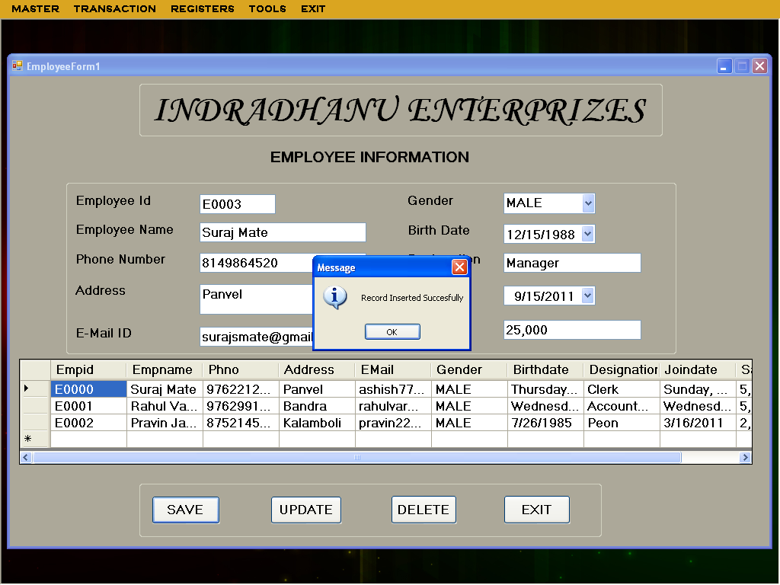

**CustomerForm.vb**

**Program Name:** CustomerForm.vb

**Program Function:** This is form is used to register customer and its details

**Data entry form:**

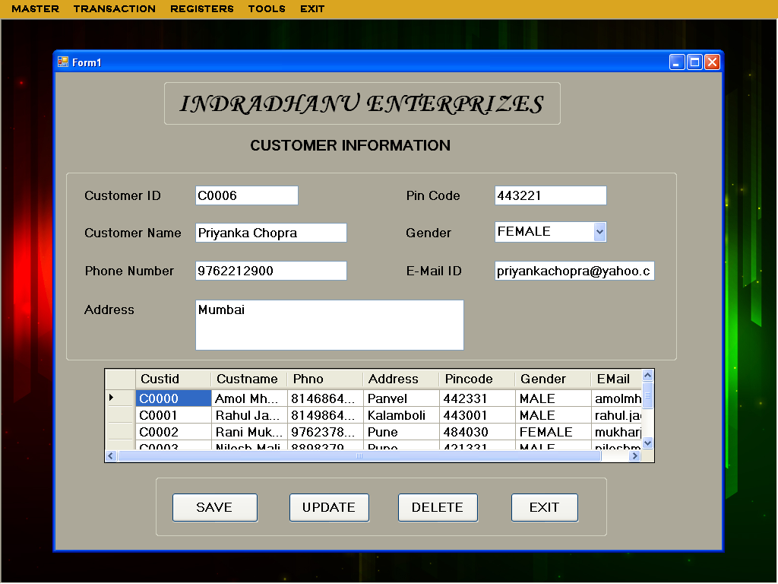

**CustomerForm.vb**

Imports System.Data.OleDb

Public Class CustomerForm

Dim h As helper = New helper

Dim dv As DataView

Private Sub CustomerForm_Load(ByVal sender As System.Object, ByVal e As System.EventArgs) Handles MyBase.Load

Dim con As OleDb.OleDbConnection = New OleDb.OleDbConnection("Provider=Microsoft.ACE.OLEDB.12.0;Data Source=|DataDirectory|\Login.accdb")

Dim cmd As OleDb.OleDbCommand = New OleDb.OleDbCommand("select * from CustomerInfo ", con)

Dim ds = New DataSet()

con.Open()

Dim da As OleDb.OleDbDataAdapter = New OleDb.OleDbDataAdapter(cmd)

da.Fill(ds, "customerInfo")

dv = New DataView(ds.Tables(0))

dgvpat.DataSource = dv

'Clear binding

'

TextBox1.DataBindings.Clear()

TextBox2.DataBindings.Clear()

TextBox3.DataBindings.Clear()

TextBox4.DataBindings.Clear()

TextBox5.DataBindings.Clear()

ComboBox1.DataBindings.Clear()

TextBox6.DataBindings.Clear()

'

'data binding

'

TextBox1.DataBindings.Add("text", dv, "Custid")

TextBox2.DataBindings.Add("text", dv, "Custname")

TextBox3.DataBindings.Add("text", dv, "Phno")

TextBox4.DataBindings.Add("text", dv, "Address")

TextBox5.DataBindings.Add("text", dv, "Pincode")

ComboBox1.DataBindings.Add("Text", dv, "Gender")

TextBox6.DataBindings.Add("text", dv, "EMail")

cmd.ExecuteNonQuery()

con.Close()

End Sub

Private Sub Button1_Click(ByVal sender As System.Object, ByVal e As System.EventArgs) Handles Button1.Click

If Button1.Text = "ADD" Then

Button1.Text = "SAVE"

TextBox1.Text = ""

TextBox2.Text = ""

TextBox3.Text = ""

TextBox4.Text = ""

TextBox5.Text = ""

ComboBox1.Text = ""

TextBox6.Text = ""

Dim con As OleDb.OleDbConnection = New OleDb.OleDbConnection("Provider=Microsoft.ACE.OLEDB.12.0;Data Source=|DataDirectory|\Login.accdb")

Dim cmd1 As OleDb.OleDbCommand = New OleDb.OleDbCommand("select max(Custid) from CustomerInfo", con)

Dim ds1 As DataSet = New DataSet()

Dim da1 As OleDb.OleDbDataAdapter = New OleDb.OleDbDataAdapter(cmd1)

con.Open()

da1.Fill(ds1, "CustomerInfo")

Dim str, code As String

Dim id As Integer

str = ds1.Tables(0).Rows(0).Item(0).ToString()

code = str.Substring(1, 4)

id = CUInt(code)

If (id >= 0 And id < 9) Then

id = id + 1

TextBox1.Text = "C000" & id

ElseIf (id >= 9 And id < 99) Then

id = id + 1

TextBox1.Text = "C00" & id

ElseIf (id >= 99 And id < 999) Then

id = id + 1

TextBox1.Text = "C0" & id

ElseIf (id > 999) Then

id = id + 1

TextBox1.Text = "C" & id

End If

cmd1.ExecuteNonQuery()

con.Close()

Else

If (TextBox2.Text = "" Or TextBox3.Text = "" Or TextBox4.Text = "" Or TextBox5.Text = "" Or ComboBox1.Text = "" Or TextBox6.Text = "") Then

MsgBox("Please Fill The Blank Field(s) !!", MsgBoxStyle.OkOnly)

Else

h.AMD("Insert into CustomerInfo values('" + TextBox1.Text + "','" + TextBox2.Text + "','" + TextBox3.Text + "','" + TextBox4.Text + "','" + TextBox5.Text + "','" + ComboBox1.Text + "','" + TextBox6.Text + "')", "Record Inserted Succesfully")

Button1.Text = "ADD"

CustomerForm_Load(Nothing, Nothing)

End If

End If

End Sub

Private Sub Button2_Click(ByVal sender As System.Object, ByVal e As System.EventArgs) Handles Button2.Click

If Button2.Text = "UPDATE" Then

Button2.Text = "MODIFY"

Dim con As OleDb.OleDbConnection = New OleDb.OleDbConnection("Provider=Microsoft.ACE.OLEDB.12.0;Data Source=|DataDirectory|\Login.accdb")

Dim cmd1 As OleDb.OleDbCommand = New OleDb.OleDbCommand("select * from CustomerInfo where Custid='" + TextBox1.Text + "'", con)

Dim ds1 As DataSet = New DataSet()

Dim da1 As OleDb.OleDbDataAdapter = New OleDb.OleDbDataAdapter(cmd1)

con.Open()

Else

h.AMD("Update CustomerInfo set Custname='" + TextBox2.Text + "',Phno='" + TextBox3.Text + "',Address='" + TextBox4.Text + "',Pincode='" + TextBox5.Text + "',Gender='" + ComboBox1.Text + "',EMail='" + TextBox6.Text + "'WHERE Custid='" + TextBox1.Text + "'", "Record Updated Succesfully")

Button2.Text = "UPDATE"

CustomerForm_Load(Nothing, Nothing)

End If

End Sub

Private Sub Button3_Click(ByVal sender As System.Object, ByVal e As System.EventArgs) Handles Button3.Click

Dim con As OleDb.OleDbConnection = New OleDb.OleDbConnection("Provider=Microsoft.ACE.OLEDB.12.0;Data Source=|DataDirectory|\Login.accdb")

Dim cmd1 As OleDb.OleDbCommand = New OleDb.OleDbCommand("select * from CustomerInfo", con)

Dim ds1 As DataSet = New DataSet()

Dim da1 As OleDb.OleDbDataAdapter = New OleDb.OleDbDataAdapter(cmd1)

con.Open()

da1.Fill(ds1, "CustomerInfo")

h.AMD("Delete From CustomerInfo where custid='" + TextBox1.Text + "' ", "Record Deleted Succesfully")

CustomerForm_Load(Nothing, Nothing)

End Sub

Private Sub Button4_Click(ByVal sender As System.Object, ByVal e As System.EventArgs) Handles Button4.Click

Dim s As String

s = MsgBox("Do You Want To EXIT", MsgBoxStyle.YesNo)

If s = vbYes Then

Me.Close()

Else

End If

End Sub

Private Sub TextBox2_KeyPress(ByVal sender As Object, ByVal e As System.Windows.Forms.KeyPressEventArgs) Handles TextBox2.KeyPress

If Char.IsLetter(e.KeyChar) = False And Asc(e.KeyChar) <> 8 And Char.IsWhiteSpace(e.KeyChar) = False Then

e.Handled = True

MsgBox("Enter Only Letters")

End If

End Sub

Private Sub TextBox3_KeyPress(ByVal sender As Object, ByVal e As System.Windows.Forms.KeyPressEventArgs) Handles TextBox3.KeyPress

If Char.IsNumber(e.KeyChar) = False And Asc(e.KeyChar) <> 8 Then

e.Handled = True

MsgBox("Enter Only Numbers")

End If

End Sub

Private Sub TextBox5_KeyPress(ByVal sender As Object, ByVal e As System.Windows.Forms.KeyPressEventArgs) Handles TextBox5.KeyPress

If Char.IsNumber(e.KeyChar) = False And Asc(e.KeyChar) <> 8 Then

e.Handled = True

MsgBox("Enter Only Numbers")

End If

End Sub

Private Sub TextBox6_KeyPress(ByVal sender As Object, ByVal e As System.Windows.Forms.KeyPressEventArgs) Handles TextBox6.KeyPress

Dim bool As Boolean

Dim email As String = TextBox6.Text.Trim

bool = ((email.Contains("@") And email.Contains(".")) And (email.IndexOf("@") < email.IndexOf(".")) _

And (email.IndexOf("@") <> email.IndexOf(".") - 1))

If bool = False Then

MsgBox("Enter Valid Email Address.", MsgBoxStyle.Exclamation, "Invalid Email Address")

TextBox6.Text = ""

End If

End Sub

End Class

**Test Result :**

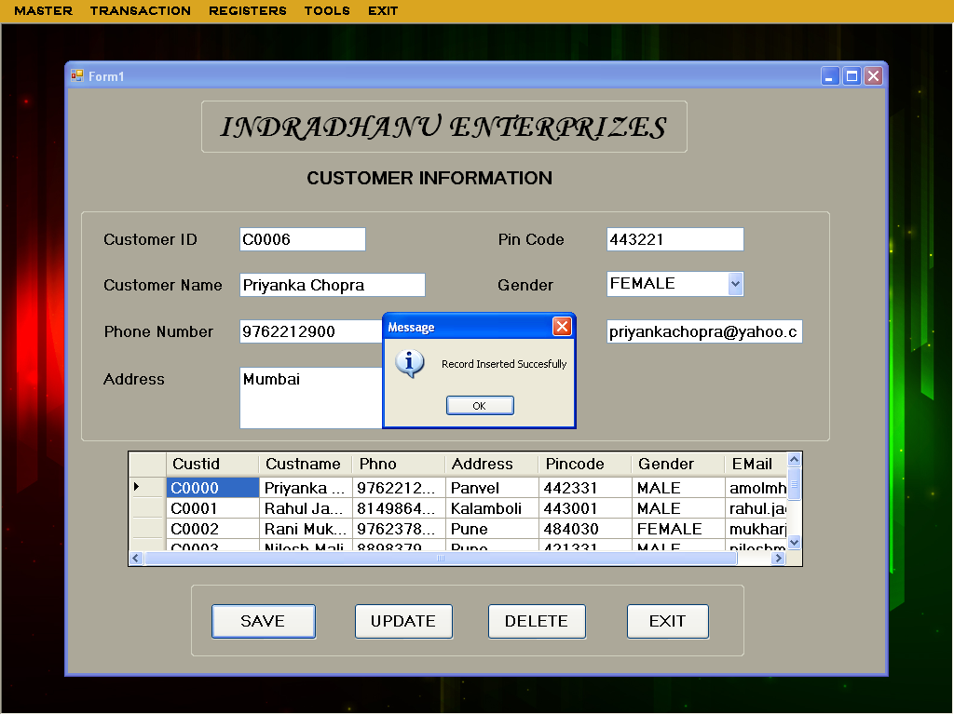

**SupplierForm.vb**

**Program Name:** SupplierForm.vb

**Program Function:** This is form is used to register Suppliers and its details

**Data entry form:**

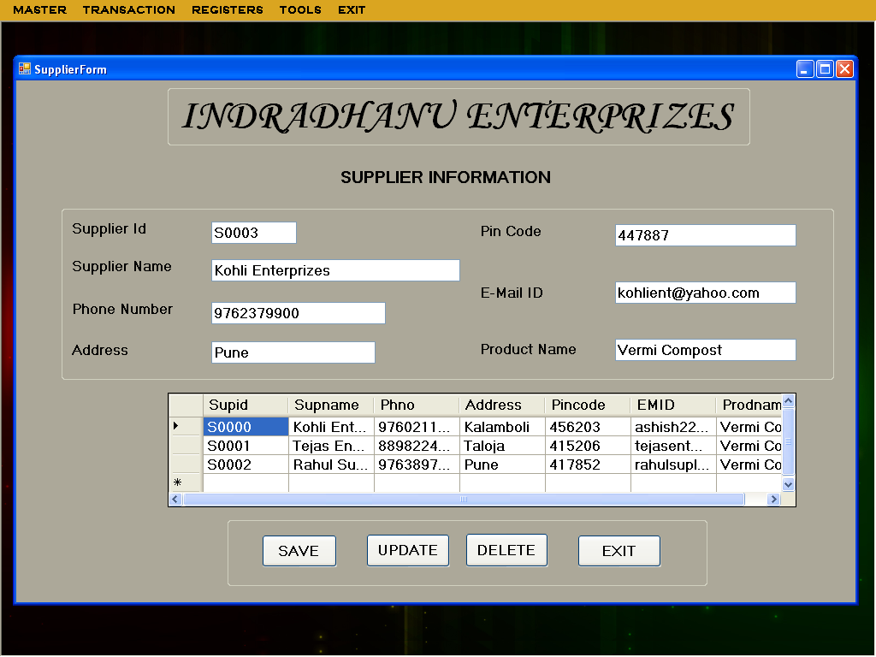

**SupplierForm.vb**

Imports System.Data.OleDb

Public Class SupplierForm

Dim h As helper = New helper

Dim dv As DataView

Private Sub SupplierForm_Load(ByVal sender As System.Object, ByVal e As System.EventArgs) Handles MyBase.Load

Dim con As OleDb.OleDbConnection = New OleDb.OleDbConnection("Provider=Microsoft.ACE.OLEDB.12.0;Data Source=|DataDirectory|\Login.accdb")

Dim cmd As OleDb.OleDbCommand = New OleDb.OleDbCommand("select * from SupplierInfo", con)

Dim ds = New DataSet()

con.Open()

Dim da As OleDb.OleDbDataAdapter = New OleDb.OleDbDataAdapter(cmd)

da.Fill(ds, "SupplierInfo")

dv = New DataView(ds.Tables(0))

dgvpat.DataSource = dv

'Clear binding

'

TextBox1.DataBindings.Clear()

TextBox2.DataBindings.Clear()

TextBox3.DataBindings.Clear()

TextBox4.DataBindings.Clear()

TextBox5.DataBindings.Clear()

TextBox6.DataBindings.Clear()

TextBox7.DataBindings.Clear()

'

'data binding

'

TextBox1.DataBindings.Add("text", dv, "Supid")

TextBox2.DataBindings.Add("text", dv, "Supname")

TextBox3.DataBindings.Add("text", dv, "Phno")

TextBox6.DataBindings.Add("text", dv, "Address")

TextBox5.DataBindings.Add("text", dv, "Pincode")

TextBox7.DataBindings.Add("text", dv, "EMID")

TextBox4.DataBindings.Add("text", dv, "Prodname")

cmd.ExecuteNonQuery()

con.Close()

End Sub

Private Sub Button1_Click(ByVal sender As System.Object, ByVal e As System.EventArgs) Handles Button1.Click

If Button1.Text = "ADD" Then

Button1.Text = "SAVE"

TextBox1.Text = ""

TextBox2.Text = ""

TextBox3.Text = ""

TextBox4.Text = ""

TextBox5.Text = ""

TextBox6.Text = ""

TextBox7.Text = ""

Dim con As OleDb.OleDbConnection = New OleDb.OleDbConnection("Provider=Microsoft.ACE.OLEDB.12.0;Data Source=|DataDirectory|\Login.accdb")

Dim cmd1 As OleDb.OleDbCommand = New OleDb.OleDbCommand("select max(Supid) from SupplierInfo", con)

Dim ds1 As DataSet = New DataSet()

Dim da1 As OleDb.OleDbDataAdapter = New OleDb.OleDbDataAdapter(cmd1)

con.Open()

da1.Fill(ds1, "SupplierInfo")

Dim str, code As String

Dim id As Integer

str = ds1.Tables(0).Rows(0).Item(0).ToString()

code = str.Substring(1, 4)

id = CUInt(code)

If (id >= 0 And id < 9) Then

id = id + 1

TextBox1.Text = "S000" & id

ElseIf (id >= 9 And id < 99) Then

id = id + 1

TextBox1.Text = "S00" & id

ElseIf (id >= 99 And id < 999) Then

id = id + 1

TextBox1.Text = "S0" & id

ElseIf (id > 999) Then

id = id + 1

TextBox1.Text = "S" & id

End If

cmd1.ExecuteNonQuery()

con.Close()

Else

If (TextBox2.Text = "" Or TextBox3.Text = "" Or TextBox4.Text = "" Or TextBox5.Text = "" Or TextBox6.Text = "" Or TextBox7.Text = "") Then

MsgBox("Please Fill The Blank Field(s) !!", MsgBoxStyle.OkOnly)

Else

h.AMD("Insert into SupplierInfo values('" + TextBox1.Text + "','" + TextBox2.Text + "','" + TextBox3.Text + "','" + TextBox4.Text + "','" + TextBox5.Text + "','" + TextBox6.Text + "','" + TextBox7.Text + "')", "Record Inserted Succesfully")

Button1.Text = "ADD"

SupplierForm_Load(Nothing, Nothing)

End If

End If

End Sub

Private Sub Button2_Click(ByVal sender As System.Object, ByVal e As System.EventArgs) Handles Button2.Click

If Button2.Text = "UPDATE" Then

Button2.Text = "MODIFY"

Dim con As OleDb.OleDbConnection = New OleDb.OleDbConnection("Provider=Microsoft.ACE.OLEDB.12.0;Data Source=|DataDirectory|\Login.accdb")

Dim cmd1 As OleDb.OleDbCommand = New OleDb.OleDbCommand("select * from SupplierInfo where Supid='" + TextBox1.Text + "'", con)

Dim ds1 As DataSet = New DataSet()

Dim da1 As OleDb.OleDbDataAdapter = New OleDb.OleDbDataAdapter(cmd1)

con.Open()

Else

h.AMD("Update SupplierInfo set Supname='" + TextBox2.Text + "',Phno='" + TextBox3.Text + "',Address='" + TextBox4.Text + "',Pincode='" + TextBox5.Text + "',EMID='" + TextBox6.Text + "',Prodname='" + TextBox7.Text + "'WHERE Supid='" + TextBox1.Text + "'", "Record Updated Succesfully")

Button2.Text = "UPDATE"

SupplierForm_Load(Nothing, Nothing)

End If

End Sub

Private Sub Button3_Click(ByVal sender As System.Object, ByVal e As System.EventArgs) Handles Button3.Click

Dim con As OleDb.OleDbConnection = New OleDb.OleDbConnection("Provider=Microsoft.ACE.OLEDB.12.0;Data Source=|DataDirectory|\Login.accdb")

Dim cmd1 As OleDb.OleDbCommand = New OleDb.OleDbCommand("select * from SupplierInfo", con)

Dim ds1 As DataSet = New DataSet()

Dim da1 As OleDb.OleDbDataAdapter = New OleDb.OleDbDataAdapter(cmd1)

con.Open()

da1.Fill(ds1, "SupplierInfo")

h.AMD("Delete From SupplierInfo where Supid='" + TextBox1.Text + "' ", "Record Deleted Succesfully")

SupplierForm_Load(Nothing, Nothing)

End Sub

Private Sub Button4_Click(ByVal sender As System.Object, ByVal e As System.EventArgs) Handles Button4.Click

Dim s As String

s = MsgBox("Do You Want To EXIT", MsgBoxStyle.YesNo)

If s = vbYes Then

Me.Close()

Else

End If

End Sub

Private Sub TextBox2_KeyPress(ByVal sender As Object, ByVal e As System.Windows.Forms.KeyPressEventArgs) Handles TextBox2.KeyPress

If Char.IsLetter(e.KeyChar) = False And Asc(e.KeyChar) <> 8 And Char.IsWhiteSpace(e.KeyChar) = False Then

e.Handled = True

MsgBox("Enter Only Letters")

End If

End Sub

Private Sub TextBox3_KeyPress(ByVal sender As Object, ByVal e As System.Windows.Forms.KeyPressEventArgs) Handles TextBox3.KeyPress

If Char.IsNumber(e.KeyChar) = False And Asc(e.KeyChar) <> 8 Then

e.Handled = True

MsgBox("Enter Only Numbers")

End If

End Sub

Private Sub TextBox5_KeyPress(ByVal sender As Object, ByVal e As System.Windows.Forms.KeyPressEventArgs) Handles TextBox5.KeyPress

If Char.IsNumber(e.KeyChar) = False And Asc(e.KeyChar) <> 8 Then

e.Handled = True

MsgBox("Enter Only Numbers")

End If

End Sub

Private Sub TextBox6_KeyPress(ByVal sender As Object, ByVal e As System.Windows.Forms.KeyPressEventArgs) Handles TextBox6.KeyPress

Dim bool As Boolean

Dim email As String = TextBox6.Text.Trim

bool = ((email.Contains("@") And email.Contains(".")) And (email.IndexOf("@") < email.IndexOf(".")) _

And (email.IndexOf("@") <> email.IndexOf(".") - 1))

If bool = False Then

MsgBox("Enter Valid Email Address.", MsgBoxStyle.Exclamation, "Invalid Email Address")

TextBox6.Text = ""

End If

End Sub

Private Sub TextBox7_KeyPress(ByVal sender As Object, ByVal e As System.Windows.Forms.KeyPressEventArgs) Handles TextBox7.KeyPress

If Char.IsLetter(e.KeyChar) = False And Asc(e.KeyChar) <> 8 And Char.IsWhiteSpace(e.KeyChar) = False Then

e.Handled = True

MsgBox("Enter Only Letters")

End If

End Sub

End Class

**Test Result :**

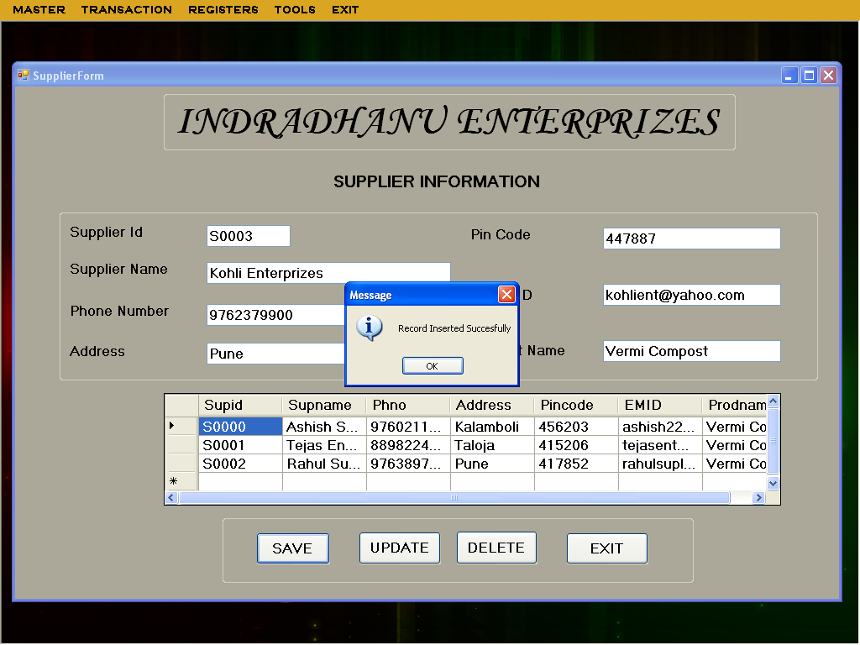

**MRNForm.vb**

**Program Name:** MRNForm.vb

**Program Function:** This is form is used to register customer and its details

**Data entry form:**

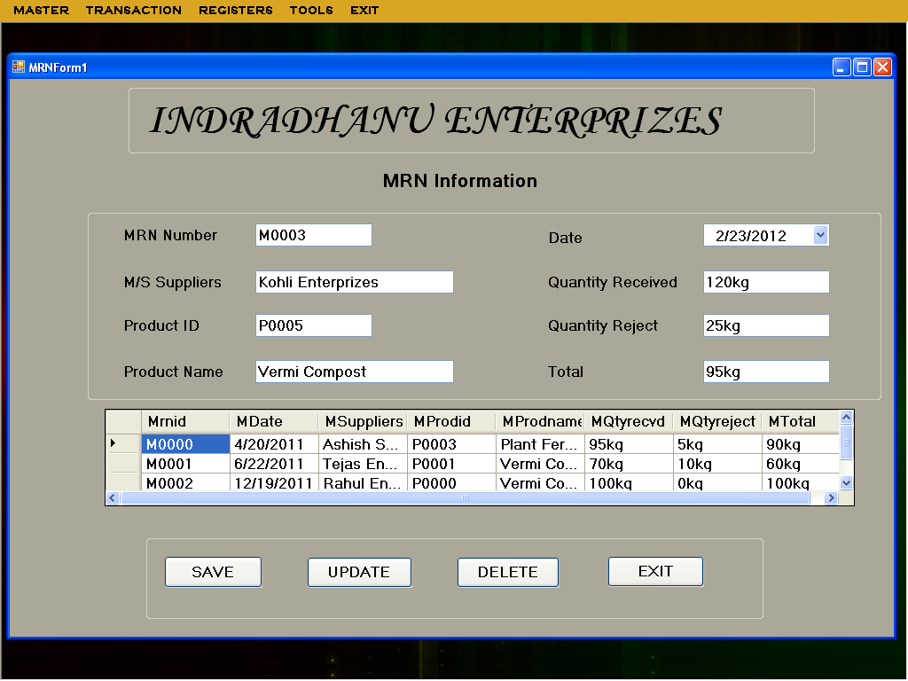

**MRNForm.vb**

Imports System.Data.OleDb

Public Class MRNForm

Dim h As helper = New helper

Dim dv As DataView

Private Sub MRNForm_Load(ByVal sender As System.Object, ByVal e As System.EventArgs) Handles MyBase.Load

Dim con As OleDb.OleDbConnection = New OleDb.OleDbConnection("Provider=Microsoft.ACE.OLEDB.12.0;Data Source=|DataDirectory|\Login.accdb")

Dim cmd As OleDb.OleDbCommand = New OleDb.OleDbCommand("select * from MRNInfo", con)

Dim ds = New DataSet()

con.Open()

Dim da As OleDb.OleDbDataAdapter = New OleDb.OleDbDataAdapter(cmd)

da.Fill(ds, "MRNInfo")

dv = New DataView(ds.Tables(0))

dgvpat.DataSource = dv

'Clear binding

'

TextBox1.DataBindings.Clear()

dtpmrn.DataBindings.Clear()

TextBox2.DataBindings.Clear()

TextBox3.DataBindings.Clear()

TextBox4.DataBindings.Clear()

TextBox5.DataBindings.Clear()

TextBox6.DataBindings.Clear()

TextBox7.DataBindings.Clear()

'

'data binding

'

TextBox1.DataBindings.Add("text", dv, "Mrnid")

dtpmrn.DataBindings.Add("text", dv, "MDate")

TextBox2.DataBindings.Add("text", dv, "MSuppliers")

TextBox3.DataBindings.Add("text", dv, "MProdid")

TextBox4.DataBindings.Add("text", dv, "MProdname")

TextBox5.DataBindings.Add("text", dv, "MQtyrecvd")

TextBox6.DataBindings.Add("text", dv, "MQtyreject")

TextBox7.DataBindings.Add("text", dv, "MTotal")

cmd.ExecuteNonQuery()

con.Close()

End Sub

Private Sub Button1_Click(ByVal sender As System.Object, ByVal e As System.EventArgs) Handles Button1.Click

If Button1.Text = "ADD" Then

Button1.Text = "SAVE"

TextBox1.Text = ""

dtpmrn.Text = ""

TextBox2.Text = ""

TextBox3.Text = ""

TextBox4.Text = ""

TextBox5.Text = ""

TextBox6.Text = ""

TextBox7.Text = ""

Dim con As OleDb.OleDbConnection = New OleDb.OleDbConnection("Provider=Microsoft.ACE.OLEDB.12.0;Data Source=|DataDirectory|\Login.accdb")

Dim cmd1 As OleDb.OleDbCommand = New OleDb.OleDbCommand("select max(Mrnid) from MRNInfo", con)

Dim ds1 As DataSet = New DataSet()

Dim da1 As OleDb.OleDbDataAdapter = New OleDb.OleDbDataAdapter(cmd1)

con.Open()

da1.Fill(ds1, "MRNInfo")

Dim str, code As String

Dim id As Integer

str = ds1.Tables(0).Rows(0).Item(0).ToString()

code = str.Substring(1, 4)

id = CUInt(code)

If (id >= 0 And id < 9) Then

id = id + 1

TextBox1.Text = "M000" & id

ElseIf (id >= 9 And id < 99) Then

id = id + 1

TextBox1.Text = "M00" & id

ElseIf (id >= 99 And id < 999) Then

id = id + 1

TextBox1.Text = "M0" & id

ElseIf (id > 999) Then

id = id + 1

TextBox1.Text = "M" & id

End If

cmd1.ExecuteNonQuery()

con.Close()

Else

If (dtpmrn.Text = "" Or TextBox2.Text = "" Or TextBox3.Text = "" Or TextBox4.Text = "" Or TextBox5.Text = "" Or TextBox6.Text = "" Or TextBox7.Text = "") Then

MsgBox("Please Fill The Blank Field(s) !!", MsgBoxStyle.OkOnly)

Else

h.AMD("Insert into MRNInfo values('" + TextBox1.Text + "','" + dtpmrn.Text + "','" + TextBox2.Text + "','" + TextBox3.Text + "','" + TextBox4.Text + "','" + TextBox5.Text + "','" + TextBox6.Text + "','" + TextBox7.Text + "')", "Record Inserted Succesfully")

Button1.Text = "ADD"

MRNForm_Load(Nothing, Nothing)

End If

End If

End Sub

Private Sub Button2_Click(ByVal sender As System.Object, ByVal e As System.EventArgs) Handles Button2.Click

If Button2.Text = "UPDATE" Then

Button2.Text = "MODIFY"

Dim con As OleDb.OleDbConnection = New OleDb.OleDbConnection("Provider=Microsoft.ACE.OLEDB.12.0;Data Source=|DataDirectory|\Login.accdb")

Dim cmd1 As OleDb.OleDbCommand = New OleDb.OleDbCommand("select * from MRNInfo where Mrnid='" + TextBox1.Text + "'", con)

Dim ds1 As DataSet = New DataSet()

Dim da1 As OleDb.OleDbDataAdapter = New OleDb.OleDbDataAdapter(cmd1)

con.Open()

Else

h.AMD("Update MRNInfo set MDate='" + dtpmrn.Text + "',MSuppliers='" + TextBox2.Text + "',MProdid='" + TextBox3.Text + "',MProdname='" + TextBox4.Text + "',MQtyrecvd='" + TextBox5.Text + "',MQtyreject='" + TextBox6.Text + "',MTotal='" + TextBox7.Text + "' WHERE Mrnid='" + TextBox1.Text + "'", "Record Updated Succesfully")

Button2.Text = "UPDATE"

MRNForm_Load(Nothing, Nothing)

End If

End Sub

Private Sub Button3_Click(ByVal sender As System.Object, ByVal e As System.EventArgs) Handles Button3.Click

Dim con As OleDb.OleDbConnection = New OleDb.OleDbConnection("Provider=Microsoft.ACE.OLEDB.12.0;Data Source=|DataDirectory|\Login.accdb")

Dim cmd1 As OleDb.OleDbCommand = New OleDb.OleDbCommand("select * from MRNInfo", con)

Dim ds1 As DataSet = New DataSet()

Dim da1 As OleDb.OleDbDataAdapter = New OleDb.OleDbDataAdapter(cmd1)

con.Open()

da1.Fill(ds1, "MRNInfo")

h.AMD("Delete From MRNInfo where Mrnid='" + TextBox1.Text + "'", "Record Deleted Succesfully")

MRNForm_Load(Nothing, Nothing)

End Sub

Private Sub Button4_Click(ByVal sender As System.Object, ByVal e As System.EventArgs) Handles Button4.Click

Dim s As String

s = MsgBox("Do You Want To EXIT", MsgBoxStyle.YesNo)

If s = vbYes Then

Me.Close()

Else

End If

End Sub

Private Sub TextBox2_KeyPress(ByVal sender As Object, ByVal e As System.Windows.Forms.KeyPressEventArgs) Handles TextBox2.KeyPress

If Char.IsLetter(e.KeyChar) = False And Asc(e.KeyChar) <> 8 And Char.IsWhiteSpace(e.KeyChar) = False Then

e.Handled = True

MsgBox("Enter Only Letters")

End If

End Sub

Private Sub TextBox4_KeyPress(ByVal sender As Object, ByVal e As System.Windows.Forms.KeyPressEventArgs) Handles TextBox4.KeyPress

If Char.IsLetter(e.KeyChar) = False And Asc(e.KeyChar) <> 8 And Char.IsWhiteSpace(e.KeyChar) = False Then

e.Handled = True

MsgBox("Enter Only Letters")

End If

End Sub

Private Sub TextBox5_KeyPress(ByVal sender As Object, ByVal e As System.Windows.Forms.KeyPressEventArgs) Handles TextBox5.KeyPress

If Char.IsNumber(e.KeyChar) = False And Asc(e.KeyChar) <> 8 Then

e.Handled = True

MsgBox("Enter Only Numbers")

End If

End Sub

Private Sub TextBox6_KeyPress(ByVal sender As Object, ByVal e As System.Windows.Forms.KeyPressEventArgs) Handles TextBox6.KeyPress

If Char.IsNumber(e.KeyChar) = False And Asc(e.KeyChar) <> 8 Then

e.Handled = True

MsgBox("Enter Only Numbers")

End If

End Sub

Private Sub TextBox7_KeyPress(ByVal sender As Object, ByVal e As System.Windows.Forms.KeyPressEventArgs) Handles TextBox7.KeyPress

If Char.IsNumber(e.KeyChar) = False And Asc(e.KeyChar) <> 8 Then

e.Handled = True

MsgBox("Enter Only Numbers")

End If

End Sub

End Class

**Test Result :**

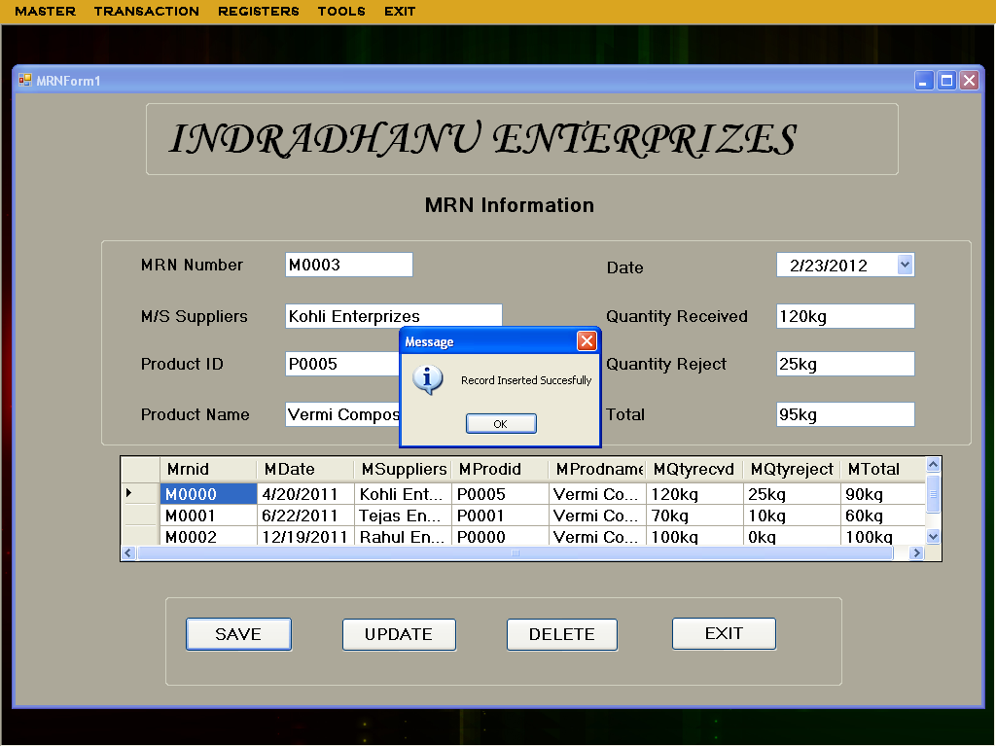

**OrderForm.vb**

**Program Name:** OrderForm.vb

**Program Function:** This is form is used to register customer Order and its details

**Data entry form:**

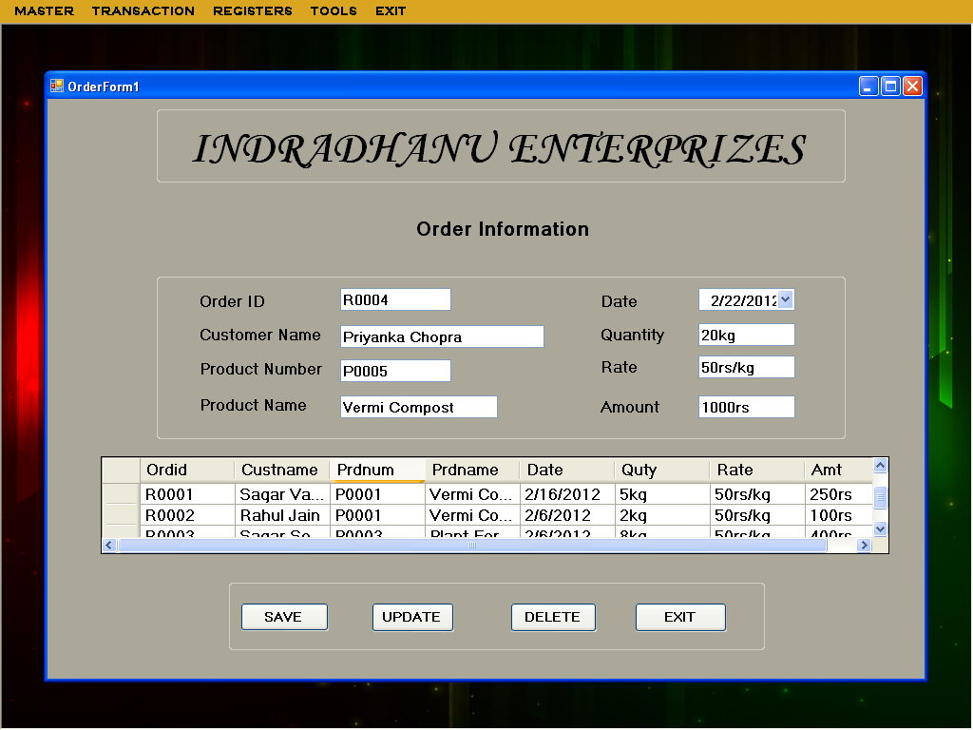

**OrderForm.vb**

Imports System.Data.OleDb

Public Class OrderForm

Dim h As helper = New helper

Dim dv As DataView

Private Sub OrderForm_Load(ByVal sender As System.Object, ByVal e As System.EventArgs) Handles MyBase.Load

Dim con As OleDb.OleDbConnection = New OleDb.OleDbConnection("Provider=Microsoft.ACE.OLEDB.12.0;Data Source=|DataDirectory|\Login.accdb")

Dim cmd As OleDb.OleDbCommand = New OleDb.OleDbCommand("select * from OrderInfo", con)

Dim ds = New DataSet()

con.Open()

Dim da As OleDb.OleDbDataAdapter = New OleDb.OleDbDataAdapter(cmd)

da.Fill(ds, "OrderInfo")

dv = New DataView(ds.Tables(0))

dgvpat.DataSource = dv

'Clear binding

'

TextBox1.DataBindings.Clear()

TextBox2.DataBindings.Clear()

TextBox3.DataBindings.Clear()

TextBox4.DataBindings.Clear()

DateTimePicker1.DataBindings.Clear()

TextBox5.DataBindings.Clear()

TextBox6.DataBindings.Clear()

TextBox7.DataBindings.Clear()

'

'data binding

'

TextBox1.DataBindings.Add("text", dv, "Ordid")

TextBox2.DataBindings.Add("text", dv, "Messers")

TextBox3.DataBindings.Add("text", dv, "Prdnum")

TextBox4.DataBindings.Add("text", dv, "Prdname")

DateTimePicker1.DataBindings.Add("text", dv, "Date")

TextBox5.DataBindings.Add("text", dv, "Quty")

TextBox6.DataBindings.Add("text", dv, "Rate")

TextBox7.DataBindings.Add("text", dv, "Amt")

cmd.ExecuteNonQuery()

con.Close()

End Sub

Private Sub Button1_Click(ByVal sender As System.Object, ByVal e As System.EventArgs) Handles Button1.Click

If Button1.Text = "ADD" Then

Button1.Text = "SAVE"

TextBox1.Text = ""

TextBox2.Text = ""

TextBox3.Text = ""

TextBox4.Text = ""

DateTimePicker1.Text = ""

TextBox5.Text = ""

TextBox6.Text = ""

TextBox7.Text = ""

Dim con As OleDb.OleDbConnection = New OleDb.OleDbConnection("Provider=Microsoft.ACE.OLEDB.12.0;Data Source=|DataDirectory|\Login.accdb")

Dim cmd1 As OleDb.OleDbCommand = New OleDb.OleDbCommand("select max(Ordid) from OrderInfo", con)

Dim ds1 As DataSet = New DataSet()

Dim da1 As OleDb.OleDbDataAdapter = New OleDb.OleDbDataAdapter(cmd1)

con.Open()

da1.Fill(ds1, "OrderInfo")

Dim str, code As String

Dim id As Integer

str = ds1.Tables(0).Rows(0).Item(0).ToString()

code = str.Substring(1, 4)

id = CUInt(code)

If (id >= 0 And id < 9) Then

id = id + 1

TextBox1.Text = "R000" & id

ElseIf (id >= 9 And id < 99) Then

id = id + 1

TextBox1.Text = "R00" & id

ElseIf (id >= 99 And id < 999) Then

id = id + 1

TextBox1.Text = "R0" & id

ElseIf (id > 999) Then

id = id + 1

TextBox1.Text = "R" & id

End If

cmd1.ExecuteNonQuery()

con.Close()

Else

If (TextBox2.Text = "" Or TextBox3.Text = "" Or TextBox4.Text = "" Or DateTimePicker1.Text = "" Or TextBox5.Text = "" Or TextBox6.Text = "" Or TextBox7.Text = "") Then

MsgBox("Please Fill The Blank Field(s) !!", MsgBoxStyle.OkOnly)

Else

h.AMD("Insert into OrderInfo values('" + TextBox1.Text + "','" + TextBox2.Text + "','" + TextBox3.Text + "','" + TextBox4.Text + "','" + DateTimePicker1.Text + "','" + TextBox5.Text + "','" + TextBox6.Text + "','" + TextBox7.Text + "')", "Record Inserted Succesfully")

Button1.Text = "ADD"

OrderForm_Load(Nothing, Nothing)

End If

End If

End Sub

Private Sub Button2_Click(ByVal sender As System.Object, ByVal e As System.EventArgs) Handles Button2.Click

If Button2.Text = "UPDATE" Then

Button2.Text = "MODIFY"

Dim con As OleDb.OleDbConnection = New OleDb.OleDbConnection("Provider=Microsoft.ACE.OLEDB.12.0;Data Source=|DataDirectory|\Login.accdb")

Dim cmd1 As OleDb.OleDbCommand = New OleDb.OleDbCommand("select * from OrderInfo where Ordid='" & TextBox1.Text & "'", con)

Dim ds1 As DataSet = New DataSet()

Dim da1 As OleDb.OleDbDataAdapter = New OleDb.OleDbDataAdapter(cmd1)

con.Open()

Else

h.AMD("Update OrderInfo set Messers='" + TextBox2.Text + "',Prdnum='" + TextBox3.Text + "',Prdname='" + TextBox4.Text + "',Date='" + DateTimePicker1.Text + "',Quty='" + TextBox5.Text + "',Rate='" + TextBox6.Text + "',Amt='" + TextBox7.Text + "'WHERE Ordid='" + TextBox1.Text + "'", "Record Updated Succesfully")

Button2.Text = "UPDATE"

OrderForm_Load(Nothing, Nothing)

End If

End Sub

Private Sub Button3_Click(ByVal sender As System.Object, ByVal e As System.EventArgs) Handles Button3.Click

Dim con As OleDb.OleDbConnection = New OleDb.OleDbConnection("Provider=Microsoft.ACE.OLEDB.12.0;Data Source=|DataDirectory|\Login.accdb")

Dim cmd1 As OleDb.OleDbCommand = New OleDb.OleDbCommand("select * from OrderInfo", con)

Dim ds1 As DataSet = New DataSet()

Dim da1 As OleDb.OleDbDataAdapter = New OleDb.OleDbDataAdapter(cmd1)

con.Open()

da1.Fill(ds1, "OrderInfo")

h.AMD("Delete From OrderInfo where Ordid='" + TextBox1.Text + "' ", "Record Deleted Succesfully")

OrderForm_Load(Nothing, Nothing)

End Sub

Private Sub Button4_Click(ByVal sender As System.Object, ByVal e As System.EventArgs) Handles Button4.Click

Dim s As String

s = MsgBox("Do You Want To EXIT", MsgBoxStyle.YesNo)

If s = vbYes Then

Me.Close()

Else

End If

End Sub

Private Sub TextBox2_KeyPress(ByVal sender As Object, ByVal e As System.Windows.Forms.KeyPressEventArgs) Handles TextBox2.KeyPress

If Char.IsLetter(e.KeyChar) = False And Asc(e.KeyChar) <> 8 And Char.IsWhiteSpace(e.KeyChar) = False Then

e.Handled = True

MsgBox("Enter Only Letters")

End If

End Sub

Private Sub TextBox4_KeyPress(ByVal sender As Object, ByVal e As System.Windows.Forms.KeyPressEventArgs) Handles TextBox4.KeyPress

If Char.IsLetter(e.KeyChar) = False And Asc(e.KeyChar) <> 8 And Char.IsWhiteSpace(e.KeyChar) = False Then

e.Handled = True

MsgBox("Enter Only Letters")

End If

End Sub

Private Sub TextBox5_KeyPress(ByVal sender As Object, ByVal e As System.Windows.Forms.KeyPressEventArgs) Handles TextBox5.KeyPress

If Char.IsNumber(e.KeyChar) = False And Asc(e.KeyChar) <> 8 Then

e.Handled = True

MsgBox("Enter Only Numbers")

End If

End Sub

Private Sub TextBox6_KeyPress(ByVal sender As Object, ByVal e As System.Windows.Forms.KeyPressEventArgs) Handles TextBox6.KeyPress

If Char.IsNumber(e.KeyChar) = False And Asc(e.KeyChar) <> 8 Then

e.Handled = True

MsgBox("Enter Only Numbers")

End If

End Sub

Private Sub TextBox7_KeyPress(ByVal sender As Object, ByVal e As System.Windows.Forms.KeyPressEventArgs) Handles TextBox7.KeyPress

If Char.IsNumber(e.KeyChar) = False And Asc(e.KeyChar) <> 8 Then

e.Handled = True

MsgBox("Enter Only Numbers")

End If

End Sub

End Class

**Test Result :**

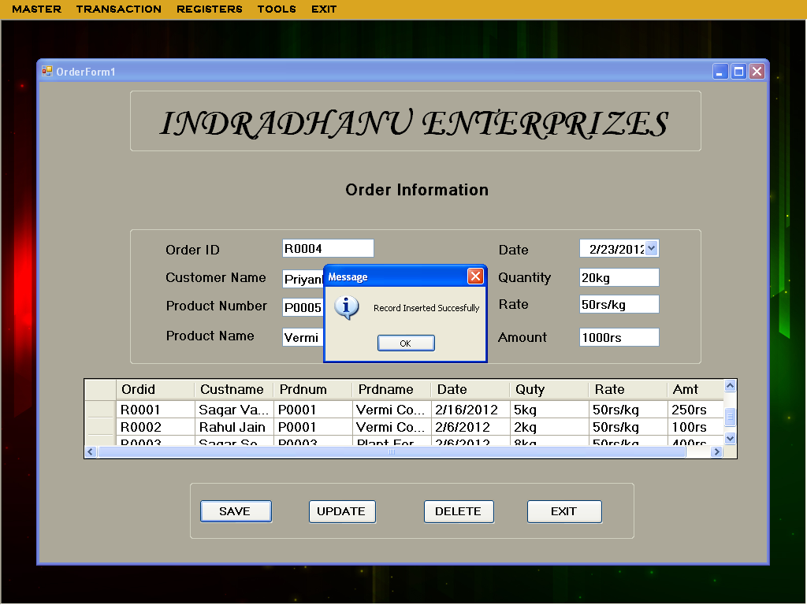

**DispatchForm.vb**

**Program Name:** DispatchForm.vb

**Program Function:** This is form is used to register Dispatch Information.

**Data entry form:**

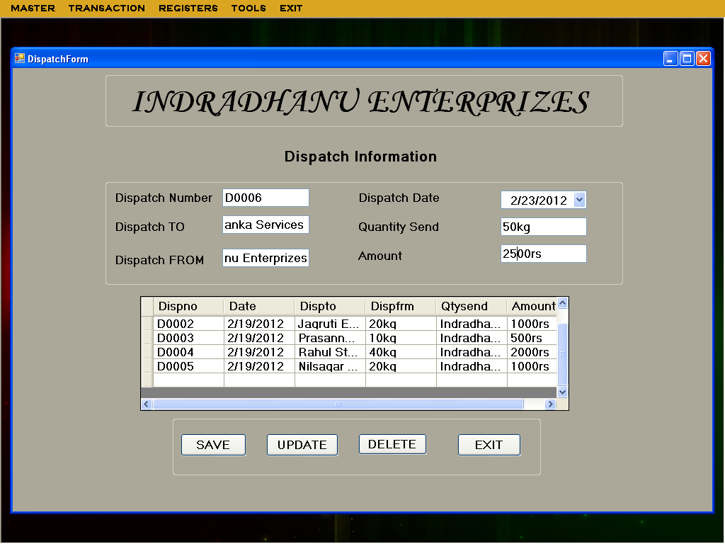

**DispatchForm.vb**

Imports System.Data.OleDb

Public Class DispatchForm

Dim h As helper = New helper

Dim dv As DataView

Private Sub DispatchForm_Load(ByVal sender As System.Object, ByVal e As System.EventArgs) Handles MyBase.Load

Dim con As OleDb.OleDbConnection = New OleDb.OleDbConnection("Provider=Microsoft.ACE.OLEDB.12.0;Data Source=|DataDirectory|\Login.accdb")

Dim cmd As OleDb.OleDbCommand = New OleDb.OleDbCommand("select * from DispatchInfo", con)

Dim ds = New DataSet()

con.Open()

Dim da As OleDb.OleDbDataAdapter = New OleDb.OleDbDataAdapter(cmd)

da.Fill(ds, "DispatchInfo")

dv = New DataView(ds.Tables(0))

dgvpat.DataSource = dv

'Clear binding

TextBox1.DataBindings.Clear()

DateTimePicker1.DataBindings.Clear()

TextBox2.DataBindings.Clear()

TextBox3.DataBindings.Clear()

TextBox4.DataBindings.Clear()

TextBox5.DataBindings.Clear()

'data binding

TextBox1.DataBindings.Add("text", dv, "Dispno")

DateTimePicker1.DataBindings.Add("text", dv, "Date")

TextBox2.DataBindings.Add("text", dv, "Dispto")

TextBox4.DataBindings.Add("text", dv, "Dispfrm")

TextBox3.DataBindings.Add("text", dv, "Qtysend")

TextBox5.DataBindings.Add("Text", dv, "Qtyrcvd")

cmd.ExecuteNonQuery()

con.Close()

End Sub

Private Sub Button1_Click(ByVal sender As System.Object, ByVal e As System.EventArgs) Handles Button1.Click

If Button1.Text = "ADD" Then

Button1.Text = "SAVE"

TextBox1.Text = ""

DateTimePicker1.Text = ""

TextBox2.Text = ""

TextBox3.Text = ""

TextBox4.Text = ""

TextBox5.Text = ""

Dim con As OleDb.OleDbConnection = New OleDb.OleDbConnection("Provider=Microsoft.ACE.OLEDB.12.0;Data Source=|DataDirectory|\Login.accdb")

Dim cmd1 As OleDb.OleDbCommand = New OleDb.OleDbCommand("select max(Dispno) from DispatchInfo", con)

Dim ds1 As DataSet = New DataSet()

Dim da1 As OleDb.OleDbDataAdapter = New OleDb.OleDbDataAdapter(cmd1)

con.Open()

da1.Fill(ds1, "DispatchInfo")

Dim str, code As String

Dim id As Integer

str = ds1.Tables(0).Rows(0).Item(0).ToString()

code = str.Substring(1, 4)

id = CUInt(code)

If (id >= 0 And id < 9) Then

id = id + 1

TextBox1.Text = "D000" & id

ElseIf (id >= 9 And id < 99) Then

id = id + 1

TextBox1.Text = "D00" & id

ElseIf (id >= 99 And id < 999) Then

id = id + 1

TextBox1.Text = "D0" & id

ElseIf (id > 999) Then

id = id + 1

TextBox1.Text = "D" & id

End If

cmd1.ExecuteNonQuery()

con.Close()

Else

If (DateTimePicker1.Text = "" Or TextBox2.Text = "" Or TextBox3.Text = "" Or TextBox4.Text = "" Or TextBox5.Text = "") Then

MsgBox("Please Fill The Blank Field(s) !!", MsgBoxStyle.OkOnly)

Else

h.AMD("Insert into DispatchInfo values('" + TextBox1.Text + "','" + DateTimePicker1.Text + "','" + TextBox2.Text + "','" + TextBox3.Text + "','" + TextBox4.Text + "','" + TextBox5.Text + "')", "Record Inserted Succesfully")

Button1.Text = "ADD"

DispatchForm_Load(Nothing, Nothing)

End If

End If

End Sub

Private Sub Button2_Click(ByVal sender As System.Object, ByVal e As System.EventArgs) Handles Button2.Click

If Button2.Text = "UPDATE" Then

Button2.Text = "MODIFY"

Dim con As OleDb.OleDbConnection = New OleDb.OleDbConnection("Provider=Microsoft.ACE.OLEDB.12.0;Data Source=|DataDirectory|\Login.accdb")

Dim cmd1 As OleDb.OleDbCommand = New OleDb.OleDbCommand("select * from DispatchInfo where Dispno='" + TextBox1.Text + "'", con)

Dim ds1 As DataSet = New DataSet()

Dim da1 As OleDb.OleDbDataAdapter = New OleDb.OleDbDataAdapter(cmd1)

con.Open()

Else

h.AMD("Update DispatchInfo set Dispto='" + TextBox2.Text + "',Date='" + DateTimePicker1.Text + "',Qtysend='" + TextBox3.Text + "',Dispfrm='" + TextBox4.Text + "',Qtyrcvd='" + TextBox5.Text + "'WHERE Dispno='" + TextBox1.Text + "'", "Record Updated Succesfully")

Button2.Text = "UPDATE"

DispatchForm_Load(Nothing, Nothing)

End If

End Sub

Private Sub Button3_Click(ByVal sender As System.Object, ByVal e As System.EventArgs) Handles Button3.Click

Dim con As OleDb.OleDbConnection = New OleDb.OleDbConnection("Provider=Microsoft.ACE.OLEDB.12.0;Data Source=|DataDirectory|\Login.accdb")

Dim cmd1 As OleDb.OleDbCommand = New OleDb.OleDbCommand("select * from DispatchInfo", con)

Dim ds1 As DataSet = New DataSet()

Dim da1 As OleDb.OleDbDataAdapter = New OleDb.OleDbDataAdapter(cmd1)

con.Open()

da1.Fill(ds1, "DispatchInfo")

h.AMD("Delete From DispatchInfo where Dispno='" + TextBox1.Text + "' ", "Record Deleted Succesfully")

DispatchForm_Load(Nothing, Nothing)

End Sub

Private Sub Button4_Click(ByVal sender As System.Object, ByVal e As System.EventArgs) Handles Button4.Click

Dim s As String

s = MsgBox("Do You Want To EXIT", MsgBoxStyle.YesNo)

If s = vbYes Then

Me.Close()

Else

End If

End Sub

Private Sub TextBox2_KeyPress(ByVal sender As Object, ByVal e As System.Windows.Forms.KeyPressEventArgs) Handles TextBox2.KeyPress

If Char.IsLetter(e.KeyChar) = False And Asc(e.KeyChar) <> 8 And Char.IsWhiteSpace(e.KeyChar) = False Then

e.Handled = True

MsgBox("Enter Only Letters")

End If

End Sub

Private Sub TextBox3_KeyPress(ByVal sender As Object, ByVal e As System.Windows.Forms.KeyPressEventArgs) Handles TextBox3.KeyPress

If Char.IsNumber(e.KeyChar) = False And Asc(e.KeyChar) <> 8 Then

e.Handled = True

MsgBox("Enter Only Numbers")

End If

End Sub

Private Sub TextBox4_KeyPress(ByVal sender As Object, ByVal e As System.Windows.Forms.KeyPressEventArgs) Handles TextBox4.KeyPress

If Char.IsLetter(e.KeyChar) = False And Asc(e.KeyChar) <> 8 And Char.IsWhiteSpace(e.KeyChar) = False Then

e.Handled = True

MsgBox("Enter Only Letters")

End If

End Sub

Private Sub TextBox5_KeyPress(ByVal sender As Object, ByVal e As System.Windows.Forms.KeyPressEventArgs) Handles TextBox5.KeyPress

If Char.IsNumber(e.KeyChar) = False And Asc(e.KeyChar) <> 8 Then

e.Handled = True

MsgBox("Enter Only Numbers")

End If

End Sub

End Class

**Test Result :**

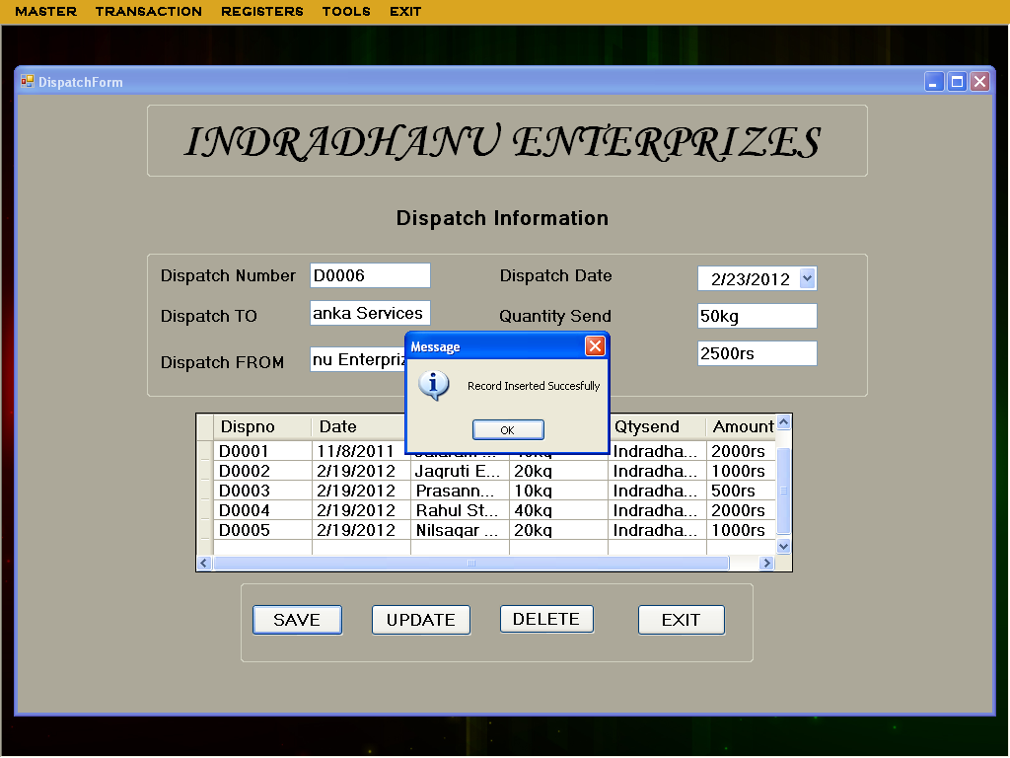

**BillForm.vb**

**Program Name:** BillForm.vb

**Program Function:** This is form is use to save bill detail.

**Data entry form:**

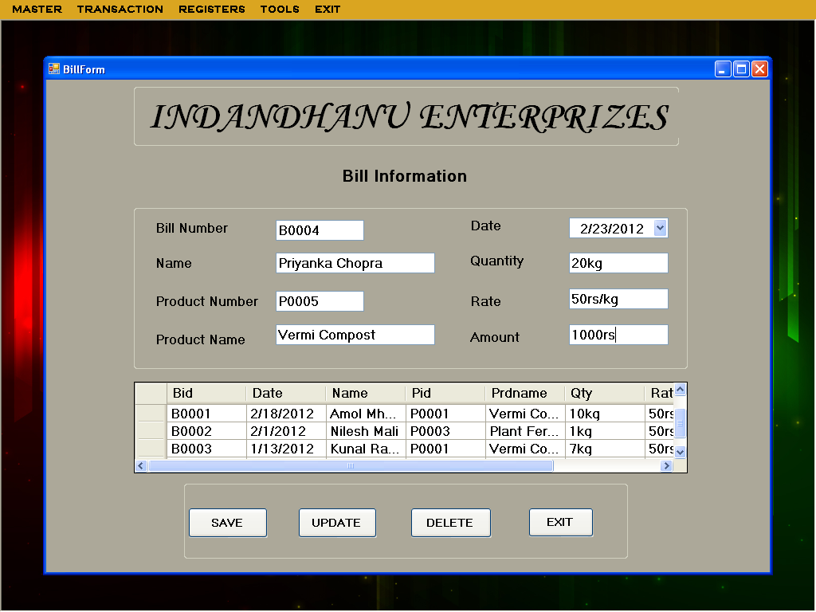

**BillForm.vb**

Imports System.Data.OleDb

Public Class BillForm

Dim h As helper = New helper

Dim dv As DataView

Private Sub BillForm_Load(ByVal sender As System.Object, ByVal e As System.EventArgs) Handles MyBase.Load

Dim con As OleDb.OleDbConnection = New OleDb.OleDbConnection("Provider=Microsoft.ACE.OLEDB.12.0;Data Source=|DataDirectory|\Login.accdb")

Dim cmd As OleDb.OleDbCommand = New OleDb.OleDbCommand("select * from BillInfo", con)

Dim ds = New DataSet()

con.Open()

Dim da As OleDb.OleDbDataAdapter = New OleDb.OleDbDataAdapter(cmd)

da.Fill(ds, "BillInfo")

dv = New DataView(ds.Tables(0))

dgvpat.DataSource = dv

'Clear binding

'

TextBox1.DataBindings.Clear()

DateTimePicker1.DataBindings.Clear()

TextBox2.DataBindings.Clear()

TextBox3.DataBindings.Clear()

TextBox4.DataBindings.Clear()

TextBox5.DataBindings.Clear()

TextBox6.DataBindings.Clear()

TextBox7.DataBindings.Clear()

'

'data binding

'

TextBox1.DataBindings.Add("text", dv, "Bid")

DateTimePicker1.DataBindings.Add("text", dv, "Date")

TextBox2.DataBindings.Add("text", dv, "Messers")

TextBox3.DataBindings.Add("text", dv, "Pid")

TextBox4.DataBindings.Add("text", dv, "Prdname")

TextBox5.DataBindings.Add("text", dv, "Qty")

TextBox6.DataBindings.Add("text", dv, "Rate")

TextBox7.DataBindings.Add("text", dv, "Amt")

cmd.ExecuteNonQuery()

con.Close()

End Sub

Private Sub Button1_Click(ByVal sender As System.Object, ByVal e As System.EventArgs) Handles Button1.Click

If Button1.Text = "ADD" Then

Button1.Text = "SAVE"

TextBox1.Text = ""

DateTimePicker1.Text = ""

TextBox2.Text = ""

TextBox3.Text = ""

TextBox4.Text = ""

TextBox5.Text = ""

TextBox6.Text = ""

TextBox6.Text = ""

Dim con As OleDb.OleDbConnection = New OleDb.OleDbConnection("Provider=Microsoft.ACE.OLEDB.12.0;Data Source=|DataDirectory|\Login.accdb")

Dim cmd1 As OleDb.OleDbCommand = New OleDb.OleDbCommand("select max(Bid) from BillInfo", con)

Dim ds1 As DataSet = New DataSet()

Dim da1 As OleDb.OleDbDataAdapter = New OleDb.OleDbDataAdapter(cmd1)

con.Open()

da1.Fill(ds1, "BillInfo")

Dim str, code As String

Dim id As Integer

str = ds1.Tables(0).Rows(0).Item(0).ToString()

code = str.Substring(1, 4)

id = CUInt(code)

If (id >= 0 And id < 9) Then

id = id + 1

TextBox1.Text = "B000" & id

ElseIf (id >= 9 And id < 99) Then

id = id + 1

TextBox1.Text = "B00" & id

ElseIf (id >= 99 And id < 999) Then

id = id + 1

TextBox1.Text = "B0" & id

ElseIf (id > 999) Then

id = id + 1

TextBox1.Text = "B" & id

End If

cmd1.ExecuteNonQuery()

con.Close()

Else

If (DateTimePicker1.Text = "" Or TextBox2.Text = "" Or TextBox3.Text = "" Or TextBox4.Text = "" Or TextBox5.Text = "" Or TextBox6.Text = ""Or TextBox7.Text = "") Then

MsgBox("Please Fill The Blank Field(s) !!", MsgBoxStyle.OkOnly)

Else

h.AMD("Insert into BillInfo values('" + TextBox1.Text + "','" + DateTimePicker1.Text + "','" + TextBox2.Text + "','" + TextBox3.Text + "','" + TextBox4.Text + "','" + TextBox5.Text + "','" + TextBox6.Text + "','" + TextBox7.Text + "')", "Record Inserted Succesfully")

Button1.Text = "ADD"

BillForm_Load(Nothing, Nothing)

End If

End If

End Sub

Private Sub Button2_Click(ByVal sender As System.Object, ByVal e As System.EventArgs) Handles Button2.Click

If Button2.Text = "UPDATE" Then

Button2.Text = "MODIFY"

Dim con As OleDb.OleDbConnection = New OleDb.OleDbConnection("Provider=Microsoft.ACE.OLEDB.12.0;Data Source=|DataDirectory|\Login.accdb")

Dim cmd1 As OleDb.OleDbCommand = New OleDb.OleDbCommand("select * from BillInfo where Bid='" + TextBox1.Text + "'", con)

Dim ds1 As DataSet = New DataSet()

Dim da1 As OleDb.OleDbDataAdapter = New OleDb.OleDbDataAdapter(cmd1)

con.Open()

Else

h.AMD("Update BillInfo Set Date='" + DateTimePicker1.Text + "',Messers='" + TextBox2.Text + "',Pid='" + TextBox3.Text + "',Prdname='" + TextBox4.Text + "',Qty='" + TextBox5.Text + "',Rate='" + TextBox6.Text + "',Amt='" + TextBox7.Text + "'WHERE Bid='" + TextBox1.Text + "'", "Record Updated Succesfully")

Button2.Text = "UPDATE"

BillForm_Load(Nothing, Nothing)

End If

End Sub

Private Sub Button3_Click(ByVal sender As System.Object, ByVal e As System.EventArgs) Handles Button3.Click

Dim con As OleDb.OleDbConnection = New OleDb.OleDbConnection("Provider=Microsoft.ACE.OLEDB.12.0;Data Source=|DataDirectory|\Login.accdb")

Dim cmd1 As OleDb.OleDbCommand = New OleDb.OleDbCommand("select * from BillInfo", con)

Dim ds1 As DataSet = New DataSet()

Dim da1 As OleDb.OleDbDataAdapter = New OleDb.OleDbDataAdapter(cmd1)

con.Open()

da1.Fill(ds1, "BillInfo")

h.AMD("Delete From BillInfo where Bid='" + TextBox1.Text + "' ", "Record Deleted Succesfully")

BillForm_Load(Nothing, Nothing)

End Sub

Private Sub Button4_Click(ByVal sender As System.Object, ByVal e As System.EventArgs) Handles Button4.Click

Dim s As String

s = MsgBox("Do You Want To EXIT", MsgBoxStyle.YesNo)

If s = vbYes Then

Me.Close()

Else

End If

End Sub

Private Sub TextBox2_KeyPress(ByVal sender As Object, ByVal e As System.Windows.Forms.KeyPressEventArgs) Handles TextBox2.KeyPress

If Char.IsLetter(e.KeyChar) = False And Asc(e.KeyChar) <> 8 And Char.IsWhiteSpace(e.KeyChar) = False Then

e.Handled = True

MsgBox("Enter Only Letters")

End If

End Sub

Private Sub TextBox4_KeyPress(ByVal sender As Object, ByVal e As System.Windows.Forms.KeyPressEventArgs) Handles TextBox4.KeyPress

If Char.IsLetter(e.KeyChar) = False And Asc(e.KeyChar) <> 8 And Char.IsWhiteSpace(e.KeyChar) = False Then

e.Handled = True

MsgBox("Enter Only Letters")

End If

End Sub

Private Sub TextBox5_KeyPress(ByVal sender As Object, ByVal e As System.Windows.Forms.KeyPressEventArgs) Handles TextBox5.KeyPress

If Char.IsNumber(e.KeyChar) = False And Asc(e.KeyChar) <> 8 Then

e.Handled = True

MsgBox("Enter Only Numbers")

End If

End Sub

Private Sub TextBox6_KeyPress(ByVal sender As Object, ByVal e As System.Windows.Forms.KeyPressEventArgs) Handles TextBox6.KeyPress

If Char.IsNumber(e.KeyChar) = False And Asc(e.KeyChar) <> 8 Then

e.Handled = True

MsgBox("Enter Only Numbers")

End If

End Sub

Private Sub TextBox7_KeyPress(ByVal sender As Object, ByVal e As System.Windows.Forms.KeyPressEventArgs) Handles TextBox7.KeyPress

If Char.IsNumber(e.KeyChar) = False And Asc(e.KeyChar) <> 8 Then

e.Handled = True

MsgBox("Enter Only Numbers")

End If

End Sub

End Class

**Test Result :**

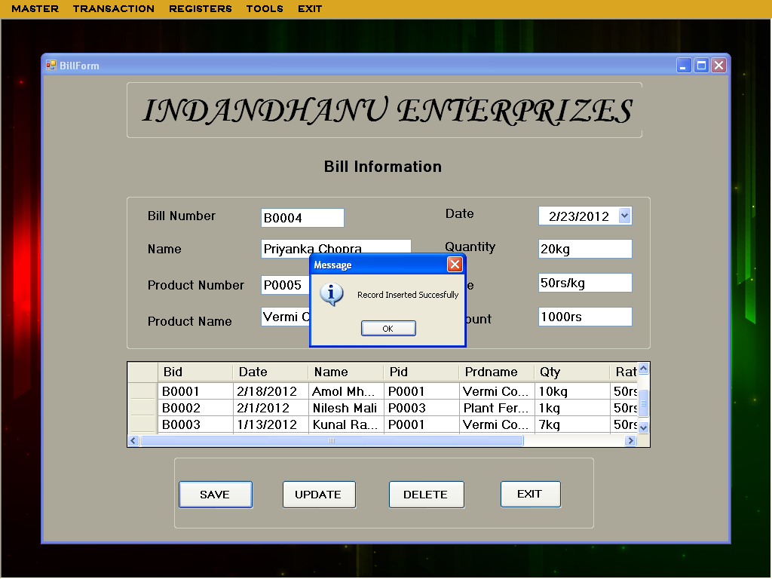

REPORTS

**Customer Detail Report**

**Report Name**:- CustReport

**Report function**: - This form displays report of all customers

Public Class CustReport

Private Sub CustReport_Load(ByVal sender As System.Object, ByVal e As System.EventArgs) Handles MyBase.Load

Dim rpt As CrystalDecisions.CrystalReports.Engine.ReportDocument

rpt = New CustReport1 'this is our report name

Dim con As New OleDb.OleDbConnection

con.ConnectionString = "Provider=Microsoft.ACE.OLEDB.12.0;Data Source=|DataDirectory|Login.accdb"

con.Open()

Dim da As New OleDb.OleDbDataAdapter("SELECT Custid,Custname,Phno,Address,Pincode,Gender,EMail " & _

" FROM CustomerInfo ", con)

Dim dt As New DataTable

da.Fill(dt)

rpt.SetDataSource(dt)

Me.CrystalReportViewer1.ReportSource = rpt

con.Close()

End Sub

End Class

**Test Result**:-

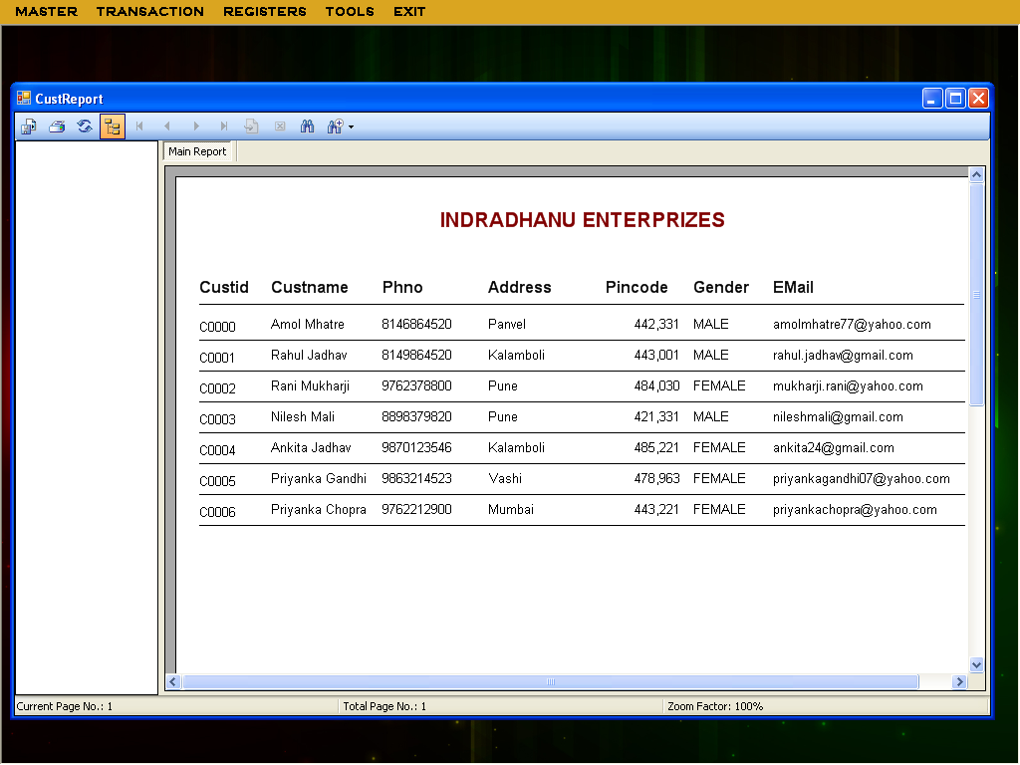

**Employee Detail Report**

**Report Name**: - EmployeeReport

**Report function**: - This report is use to print & show the list of the employee

Public Class EmployeeReport

Private Sub EmployeeReport_Load(ByVal sender As System.Object, ByVal e As System.EventArgs) Handles MyBase.Load

Dim rpt As CrystalDecisions.CrystalReports.Engine.ReportDocument

rpt = New CustReport1 'this is our report name

Dim con As New OleDb.OleDbConnection

con.ConnectionString = "Provider=Microsoft.ACE.OLEDB.12.0;Data Source=|DataDirectory|Login.accdb"

con.Open()

Dim da As New OleDb.OleDbDataAdapter("SELECT Custid,Custname,Phno,Address,Pincode,Gender,EMail " & _

" FROM EmployeeInfo ", con)

Dim dt As New DataTable

da.Fill(dt)

rpt.SetDataSource(dt)

Me.CrystalReportViewer1.ReportSource = rpt

con.Close()

End Sub

End Class

**Test Result:-**

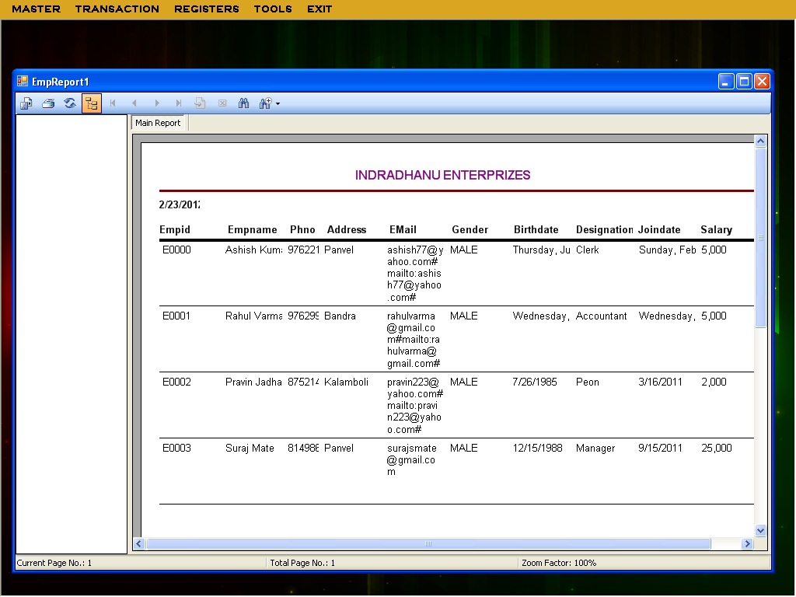

**Supplier Detail Report**

**Report Name**:- SupplierReport

**Report function**: - This form displays report of all Suppliers.

Public Class SupplierReport

Private Sub SupplierReport_Load(ByVal sender As System.Object, ByVal e As System.EventArgs) Handles MyBase.Load

Dim rpt As CrystalDecisions.CrystalReports.Engine.ReportDocument

rpt = New SupplierReport1 'this is our report name

Dim con As New OleDb.OleDbConnection

con.ConnectionString = "Provider=Microsoft.ACE.OLEDB.12.0;Data Source=|DataDirectory|Login.accdb"

con.Open()

Dim da As New OleDb.OleDbDataAdapter("SELECT Supid,Supname,Phno,Address,Pincode,EMID,Prodname " & _

" FROM SupplierInfo ", con)

Dim dt As New DataTable

da.Fill(dt)

rpt.SetDataSource(dt)

Me.CrystalReportViewer1.ReportSource = rpt

con.Close()

End Sub

End Class

**Test Result**:-

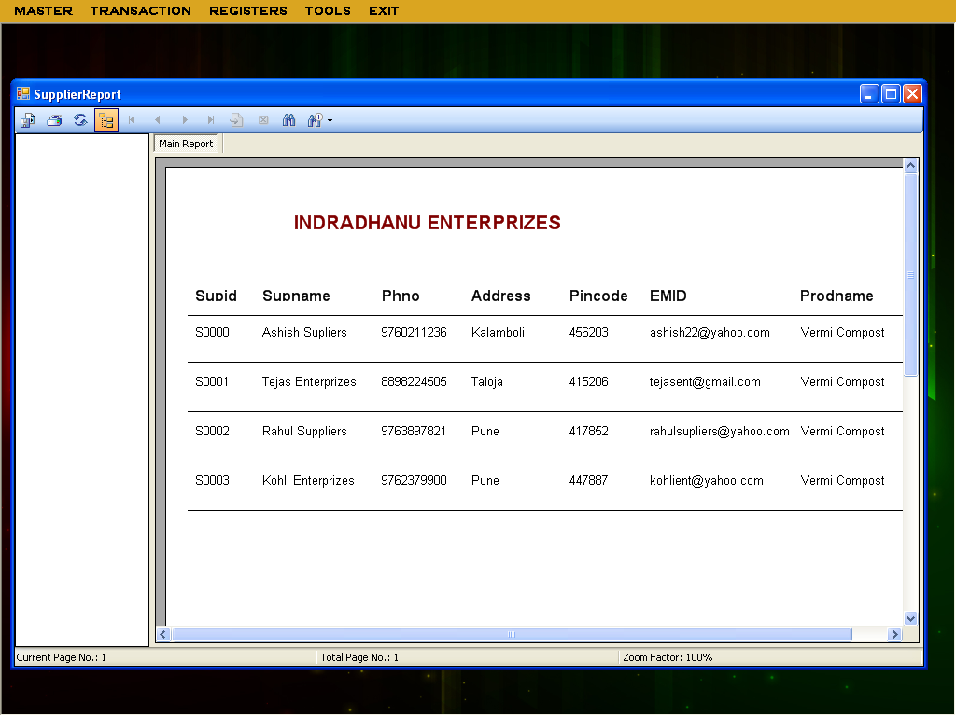

**Bill Detail Report**

**Report Name**: - BillReport

**Report function**: - This report is use to print & show the Bill of the Product.

Public Class BillReport

Private Sub BillReport_Load(ByVal sender As System.Object, ByVal e As System.EventArgs) Handles MyBase.Load

Dim rpt As CrystalDecisions.CrystalReports.Engine.ReportDocument

rpt = New BillReport1 'this is our report name

Dim con As New OleDb.OleDbConnection

con.ConnectionString = "Provider=Microsoft.ACE.OLEDB.12.0;Data Source=|DataDirectory|Login.accdb"

con.Open()

Dim da As New OleDb.OleDbDataAdapter("SELECT Bid,Date,Name,Pid,Prdname,Qty,Rate,Amt " & _

" FROM BillInfo ", con)

Dim dt As New DataTable

da.Fill(dt)

rpt.SetDataSource(dt)

Me.CrystalReportViewer1.ReportSource = rpt

con.Close()

End Sub

End Class

**Test Result:-**

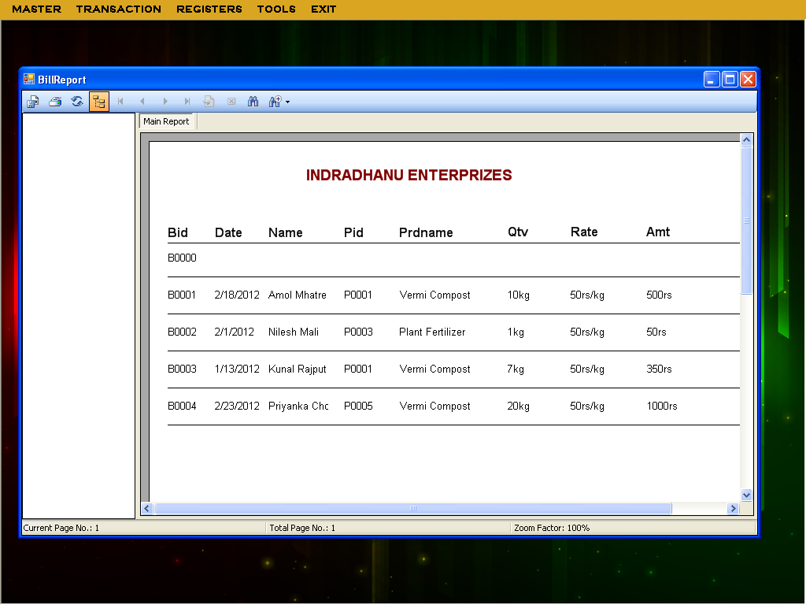

**VALIDATIONS**

**Validations made to the system enable us to get rid of number of frequently made mistakes. Validation prevents the further complications those may occur. It helps the new user to enter proper data into the system.**

**Security at login form:**

**For the security purpose the login form is used where the user should enter proper user name and password. According to different users different authentications will be provided to the respective user. If the user is entering wrong user name or password to the system, then system will get ended.**

**At form load event:**

**At the form load event all the text boxes and combo boxes which are used for showing the information from the respective table, are disabled so that the user cannot make changes to the text appearing in the text boxes. While traversing through the records or searching and sorting the records these records will remain disabled.**

**Addition of new record:**

**While adding a new record to any form causes all other buttons to be disabled and all the text boxes and combo boxes to be enabled. So that all the attributes will get added by the user and at the same time the user cannot click on any other button.**

**Text boxes:**

**While entering the information into the respective text boxes validations for numbers and alphabets (accordingly) are done. So that some text boxes are made to display only alphabetical value and some are made to display only numbers. Further if the text box is displaying mobile number then it should contain 10 digits. The text boxes which are supposed to show the alphabetical values like name will show only alphabets if the user is trying to enter any numerical value it will not be displayed in that text box. Whenever required the tool tips are used to guide the new user.**

**Combo boxes:**

**At some places the combo boxes are also used to enter the information into the tables. These combo boxes can be classified into two groups.**

**The combo boxes used to show the static data.**

**Some attributes in the table are guarded by the check constraint so that the value that will be entered by the user should be something from the given set. For example type of the STATUS should be in ATTENDED, UNATTENDED so user is not allowed to enter any other value. At this point the combo boxes are useful. We can enter the static data into the collection property of the respective combo box at design time itself as that will not be getting changed at all. These are the combo boxes handling static data according to the system.**

**The combo boxes used to show the (dynamic) data from other table.**

**Some attributes in one table are the foreign keys from the other tables which act as reference for that table. These values are totally depending on other table. So the values entered by the user for this attribute should be present in the referenced table. It is the tedious job to see the records present in other form to enter data in present form. Instead of switching from one form to another, it is better to have all the records on present form. This can be done using combo boxes. Combo boxes will contain only those values which are entered in the referenced table. If the values are deleted from the referenced table then the respective updating should be performed on present form. This data is set at run time and can get changed time to time. These are the combo boxes handling dynamic data according to the system.**

**Date time picker:**

**This component of vb.net allows the user to select date at run time. Its format should also match to the back end that is Oracle 10G’s date data type. At some places when the allottee is lodging complaint the date should match to the current date. These things are taken care and cannot be changed. Date time picker is also used for setting reminder. Reminder can be set for today and further dates.**

**Testing**

**It is the process of executing a program with the intent of finding errors.**

**Testing is performed to ensure that the system meet need of the organization and the end user**

**Its checks-Is a program doing what it is supposed to do and is not doing what it is not supposed to do?**

**And also validates that the right system was built.**

**Testing Process**

**Step1-Set the Test Objectives**

**Step2-Develop the Test Plan**

**Step3-Execute tests**

**Step4-Evalute/Report Test Results**

**Functional Testing (also known as Black Book Testing) are often used to find bugs in high-level operations, at the level of the features, operational profiles, and customer scenarios.**

**Where as unit Testing is performed on a single unit.**

**This Unit is a functional area comprising of one or more programs.**

**The focus of this testing is on the testing is on the unit and not on the interaction between the unit i.e. it focuses the effort on the smallest unit of software design.**

**We performed both functional and unit testing by using test cases and test plan provided by the MGM College.**

LIMITATIONS & FUTURE ENHANCEMENT

**Limitations of the Proposed System:**

* **The full system is totally depended on the person using the system. So any other user may not be able to fully utilize the system conveniently since he/she may not be able to follow the features of the system.**
* **The system is not connected with the existing Accounting department of the Organization.**
* **The proposed system does not support the networking facilities.**
* **Since the proposed system is computerized system, any power disturbance**

**occurred may cause the loss of important information, if the data is not saved.**

* **The proposed system cannot do some manual task such as taking the decision of order placement, comparing quotations, deciding on how much percentage to offer on which deal.**

**Future Enhancement:**

* **Barcode Support.**
* **Network Support – You can use more than one computer**
* **Quickly create database backup.**
* **Multilanguage Support.**
* **Making project to run in different resolution**

# The software can be compatible for online transaction also.

# It can be used for any product and does not get affected by seasons.

# Account of different customers and vendors can be maintained.

**CONCLUSION**

It’s been a long way since humans first used computers in their day-to-day lives.

Computerization helps us to stay with the world not lag behind it.

The project “**FERTILIZER SHOP SYSTEM** ” has been developed on the same principal of automating the daily work. It aims to simplify and enhance their working without compromising quality, accuracy and security.

The system is user friendly, robust and secure. It has been tested in all sorts of scenarios ranging from valid data to invalid and meaningless data. The system is also able to trap common errors which occur in normal office environment.

This is a complete package which is up to the mark of the current industry standards and most important of all is that it met its user’s requirement.

BIBLIOGRAPHY

**Books Referred:-**

* **THE COMPLETE REFRENCE VISUAL BASIC 6.**

**BY NOEL JERKE.**

* **THE ANALYSIS DESIGN & IMPLEMENTATION OF INFORMATION SYSTEM.**

**BY HENRY C LUCAS.**

* **SAYSTEM ANALYSIS & DESIGN.**

**BY ELIAS M AVAD.**

* **MICROSOFT ACCESS REFRENCE BOOK.**

**BY SSI & NIIT.**

**Websites Referred: -**

* **WWW.GOOGLE.COM**
* **Microsoft Developer Networking (MSDN)**